# **Preprocessing Unstructured Data for LLM Applications**

## **Overview of LLM Data Preprocessing**

<https://www.coursera.org/projects/preprocessing-unstructured-data-for-llm-applications>

<https://learn.deeplearning.ai/courses/preprocessing-unstructured-data-for-llm-applications/lesson/xs32e/introduction>

<https://github.com/Josesosa0777/preprocess_unstructured_data_for_llm>

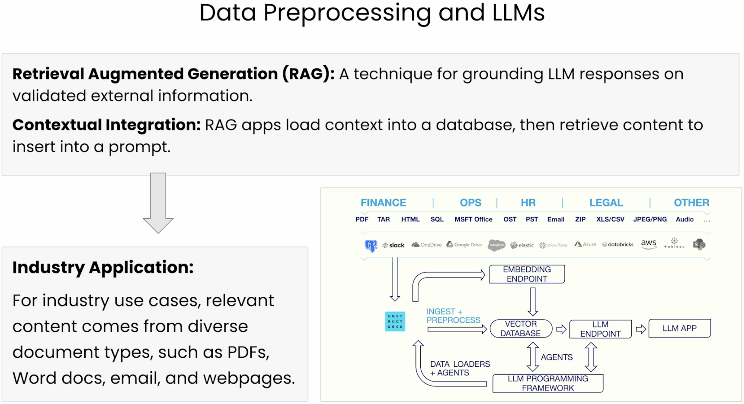

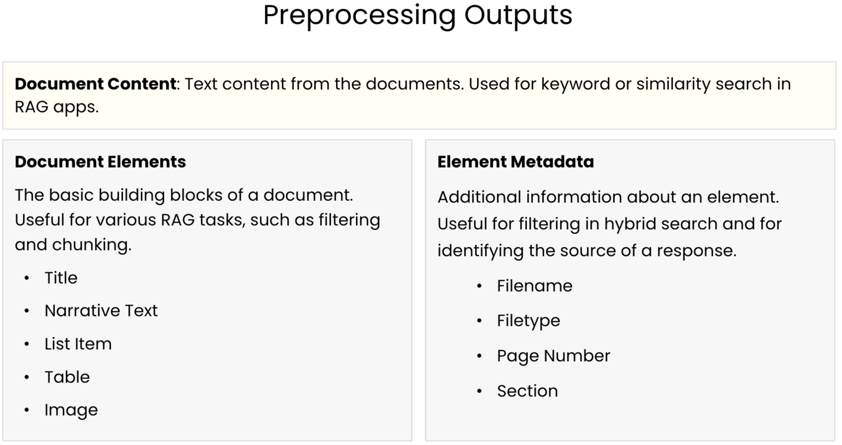

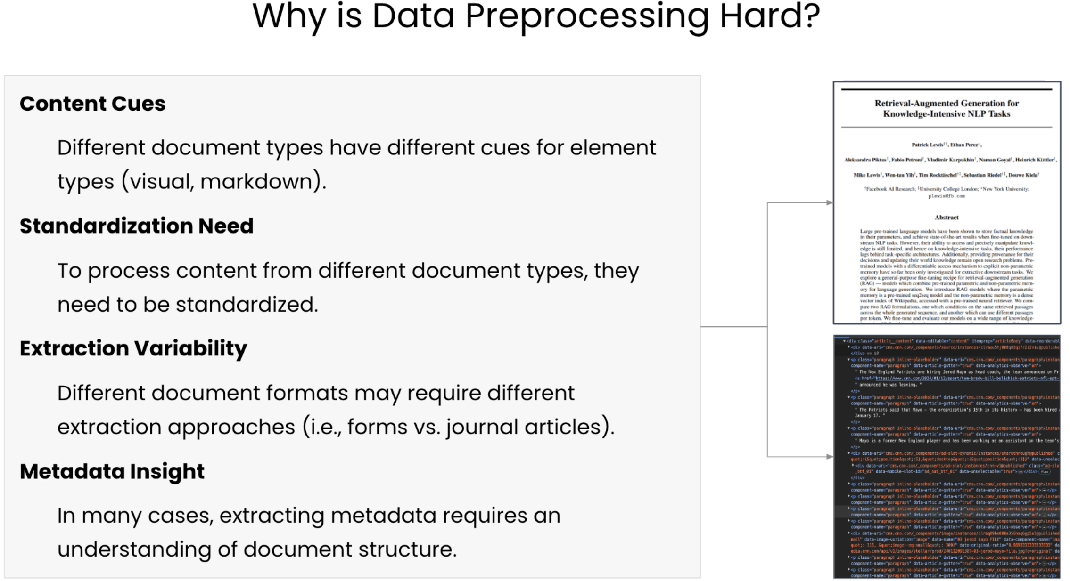

## **Normalizing the content**

**Normalizing Diverse Documents**

**Format Diversity:** Documents come in a variety of formats (PDF, Word, EPUB, Markdown, etc.)

**Common Format:** The first step in preprocessing is to convert raw documents into a common format that identifies common document elements, like titles and narrative text.

**Normalization Benefit:** Normalized format allows any document to be processed in the same way, regardless of the source format.

* Filtering out unwanted elements, like headers and footer
* Chunking document elements into sections

**Reduced Processing Cost:** The initial document preprocessing steps is the most expensive part of the process.

* Downstream tasks like chunking are inexpensive operations on normalized outputs.
* Enables experiment with many different chunking techniques without reprocessing documents.

**Data Serialization**

**Serialization Benefits:** Serialization allows the results of document preprocessing to be used again later.

*Advantages of JSON*

* ﻿﻿Structure is common and well understood
* ﻿﻿Is a standard HTTP response
* ﻿﻿Able to be used in multiple programming languages
* ﻿Can be converted to JSONL for streaming use cases

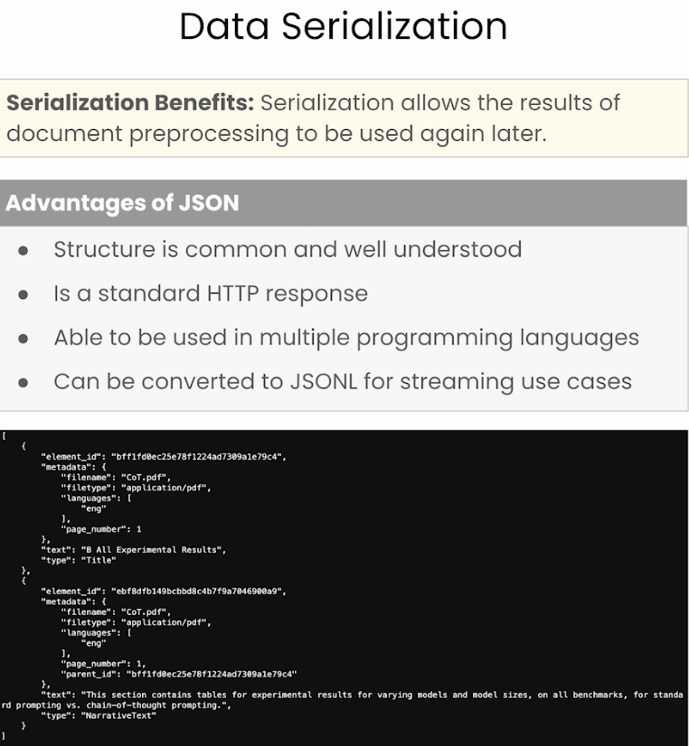

**HTML Page**

**LLM Relevance:** Integrating fresh Internet data into Large Language Models (LLMs) to maintain their correctness and relevance.

**HTML Understanding:** Essential for structuring web content, using elements like <h1> for titles and <p> for text.

**Data Extraction and Categorization:** Analyzing HTML elements to extract and organize web content into structured formats for relevant information distillation.

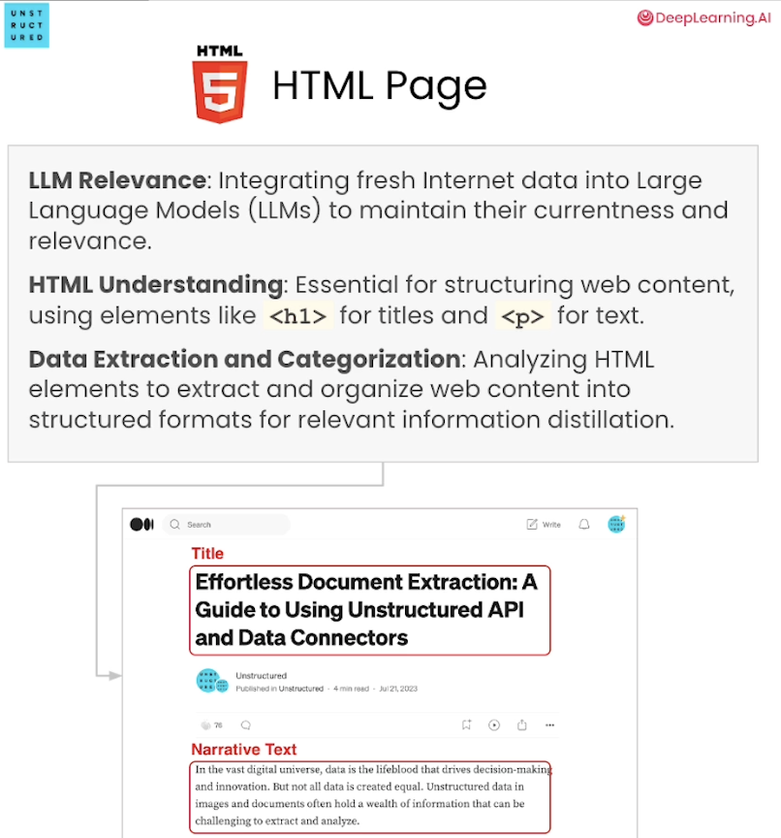

**MS Power Point**

**Professional Use:** Widely used in consulting to present ideas, strategies, and results, crucial for enhancing LLMs' knowledge base.

**Extraction Process:** Involves parsing elements like bulleted paragraphs, slide notes, shapes, and tables in PowerPoint slides.

**Tool Utilization:** Python libraries, such as ppt, navigate and extract textual or visual information from slides.

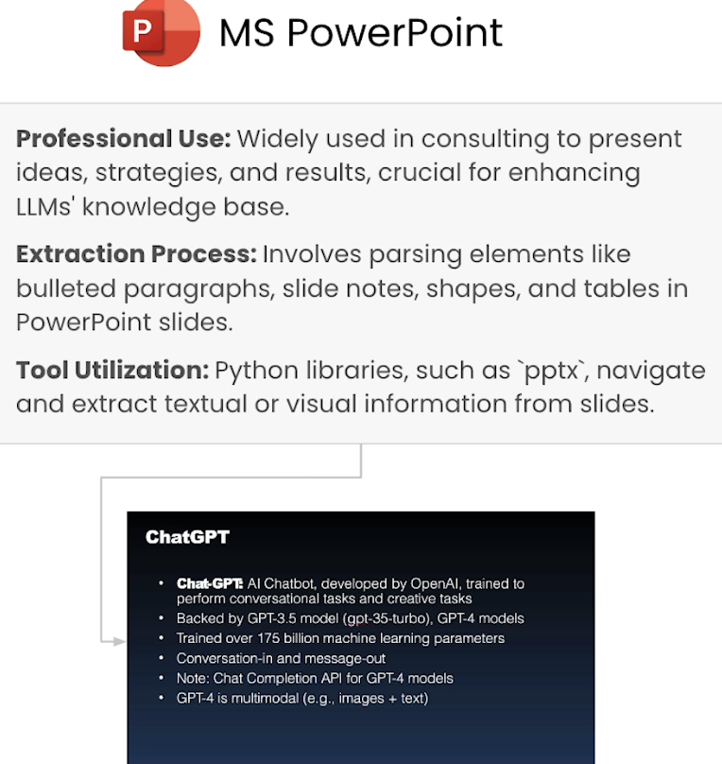

**PDF with Complex Layout and Tables**

**PDF Characteristics**

* Maintains consistent formatting across devices
* Complex structures with diverse layouts, including text, images, and tables in non-sequential order.

**Extraction Tools and Libraries**

* Facilitate text and element extraction
* Preserve context and layout, distinguishing between main text, headers, footers, and side notes.

**Advanced Capabilities:** Use OCR and Transformer-based technology.

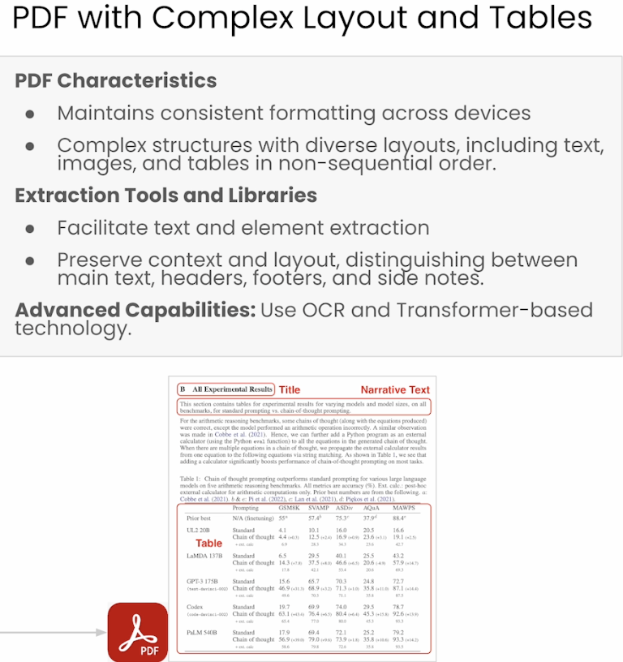

**# Warning control**

**import warnings**

**warnings.filterwarnings('ignore')**

**from IPython.display import JSON**

**import json**

**from unstructured_client import UnstructuredClient**

**from unstructured_client.models import shared**

**from unstructured_client.models.errors import SDKError**

**from unstructured.partition.html import partition_html**

**from unstructured.partition.pptx import partition_pptx**

**from unstructured.staging.base import dict_to_elements, elements_to_json**

**from Utils import Utils**

**utils = Utils()**

**DLAI_API_KEY = utils.get_dlai_api_key()**

**DLAI_API_URL = utils.get_dlai_url()**

**s = UnstructuredClient(**

**api_key_auth=DLAI_API_KEY,**

**server_url=DLAI_API_URL,**

**)**

**Example Document: Medium Blog HTML Page**

**from IPython.display import Image**

**Image(filename="images/HTML_demo.png", height=600, width=600)**

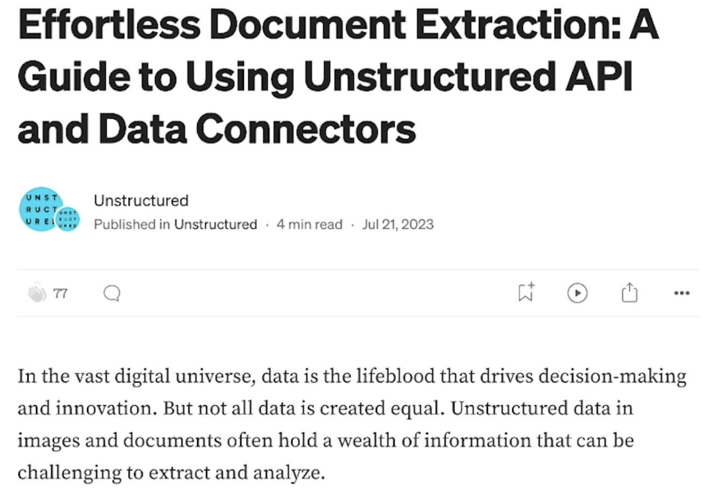

**filename = "example_files/medium_blog.html"**

**elements = partition_html(filename=filename)**

**element_dict = [el.to_dict() for el in elements]**

**example_output = json.dumps(element_dict[11:15], indent=2)**

**print(example_output)**

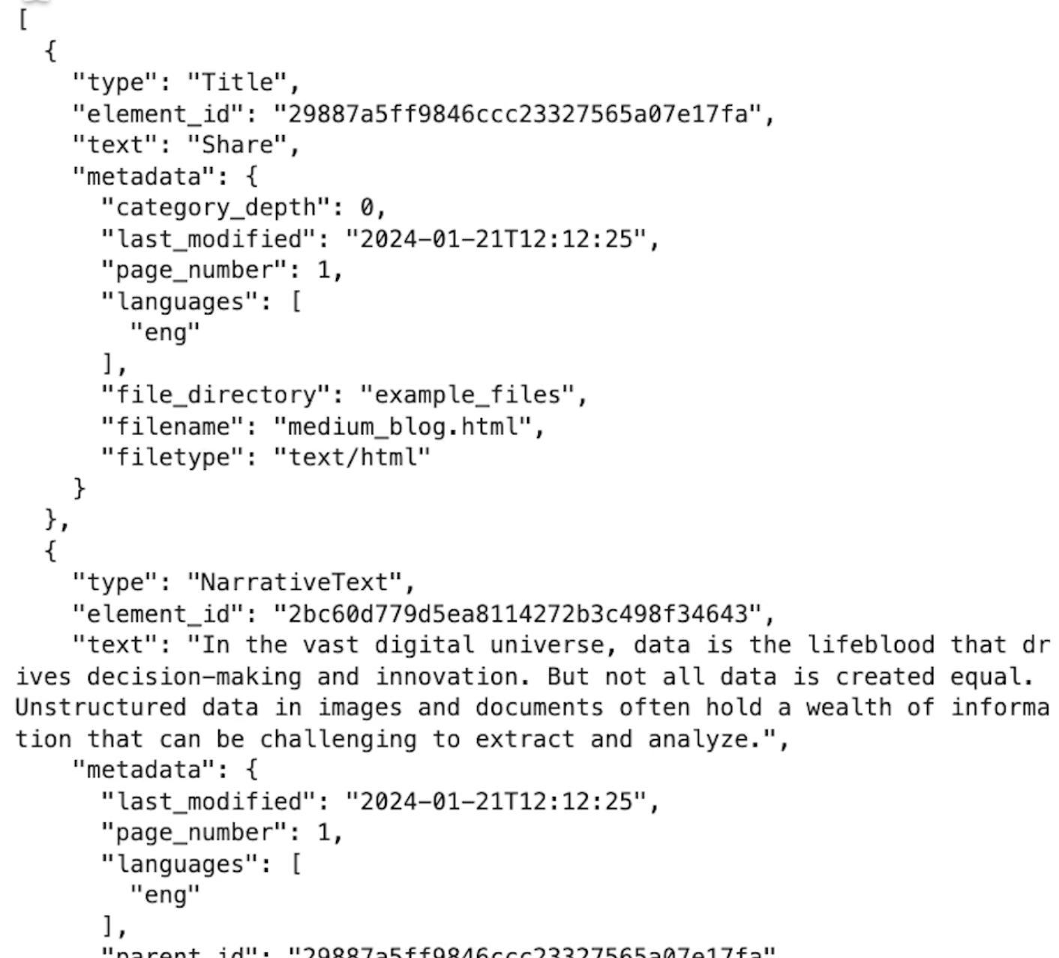

**JSON(example_output)**

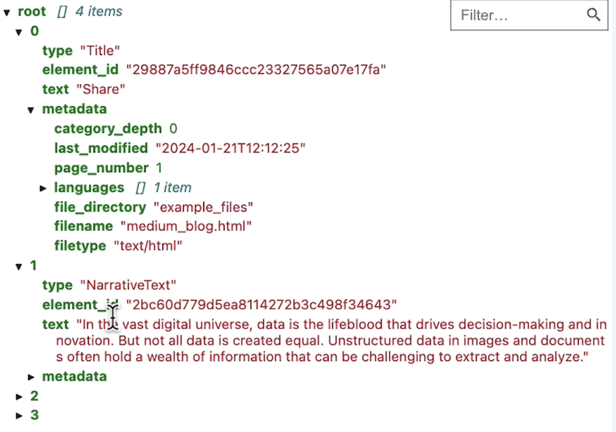

**Example Doc: MSFT PowerPoint on OpenAI**

**Image(filename="images/pptx_slide.png", height=600, width=600)**

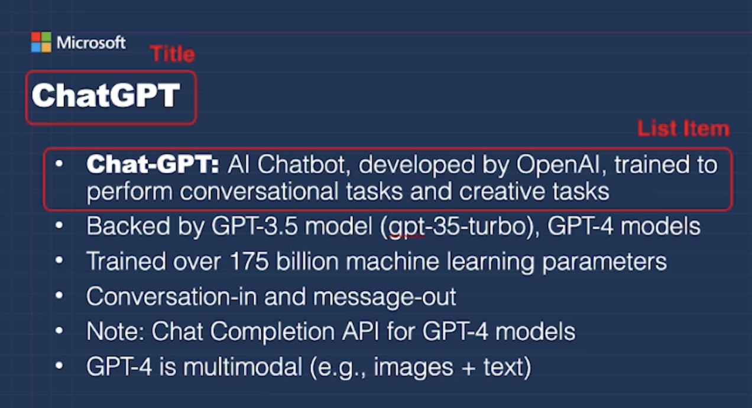

**filename = "example_files/msft_openai.pptx"**

**elements = partition_pptx(filename=filename)**

**element_dict = [el.to_dict() for el in elements]**

**JSON(json.dumps(element_dict[:], indent=2))**

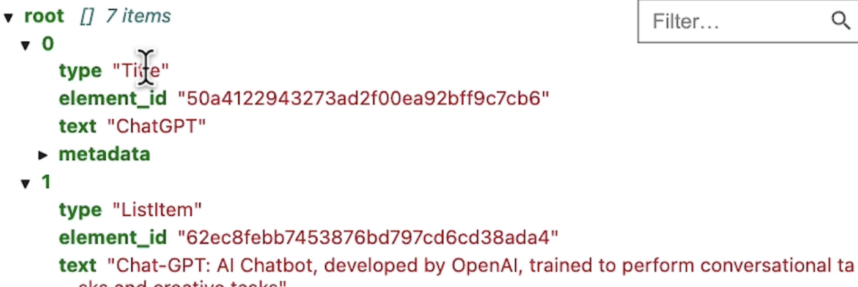

**Example Document: PDF on Chain-of-Thought**

**Image(filename="images/cot_paper.png", height=600, width=600)**

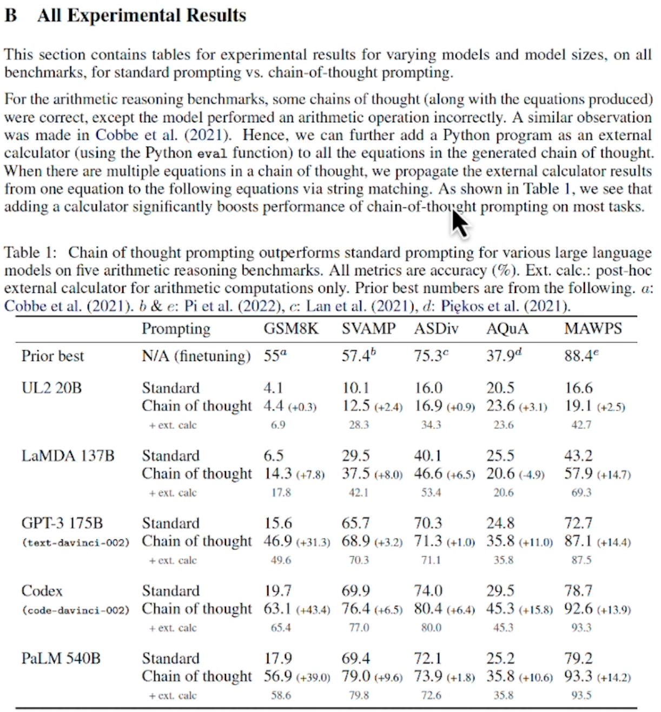

**filename = "example_files/CoT.pdf"**

**with open(filename, "rb") as f:**

**files=shared.Files(**

**content=f.read(),**

**file_name=filename,**

**)**

**req = shared.PartitionParameters(**

**files=files,**

**strategy='hi_res',**

**pdf_infer_table_structure=True,**

**languages=["eng"],**

**)**

**try:**

**resp = s.general.partition(req)**

**print(json.dumps(resp.elements[:3], indent=2))**

**except SDKError as e:**

**print(e)**

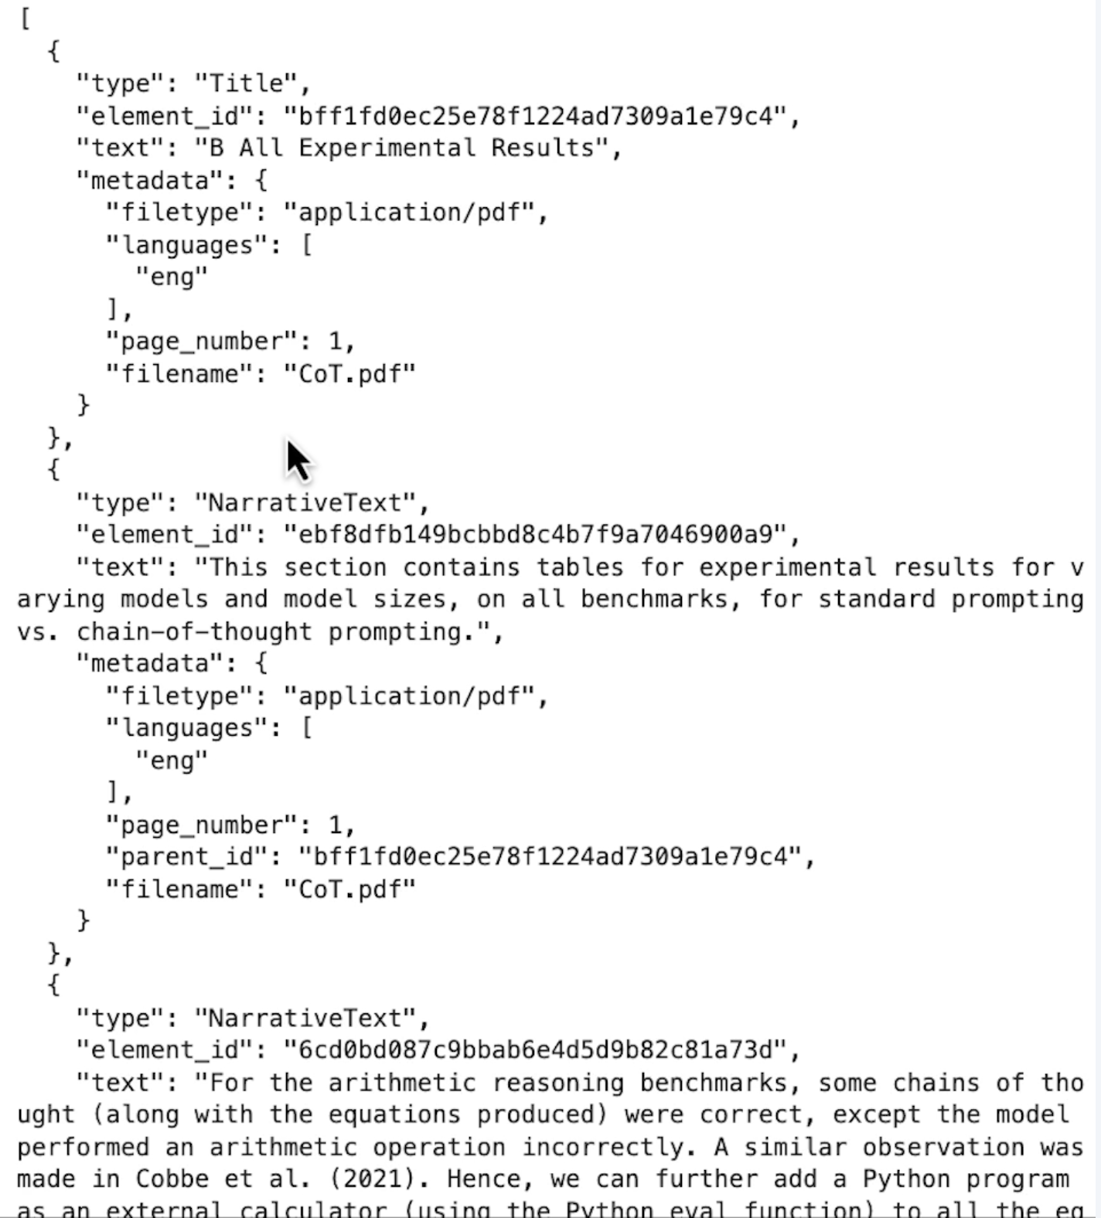

**JSON(json.dumps(resp.elements, indent=2))**

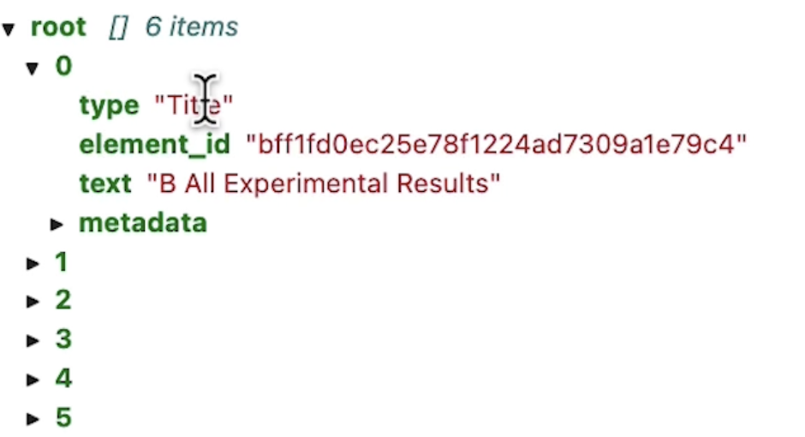

**Work With Your Own Files**

**import panel as pn**

**#import param**

**from Utils import upld_file**

**pn.extension()**

**upld_widget = upld_file()**

**pn.Row(upld_widget.widget_file_upload)**

**!ls ./example_files**

## **Metadata extraction and chunking**

**What is metadata?**

**Document Details:** Metadata provides additional information about content extract from source documents.

**Source Identification:** One type of metadata is information about the document itself, such as filename, source URL, or filetype.

**Structural Metadata:** Metadata be constructed from the structure of the document.

*Examples:* element type, hierarchy information, and section information.

**Search Enhancement:** In RAG systems, metadata provides filtering options for hybrid search.

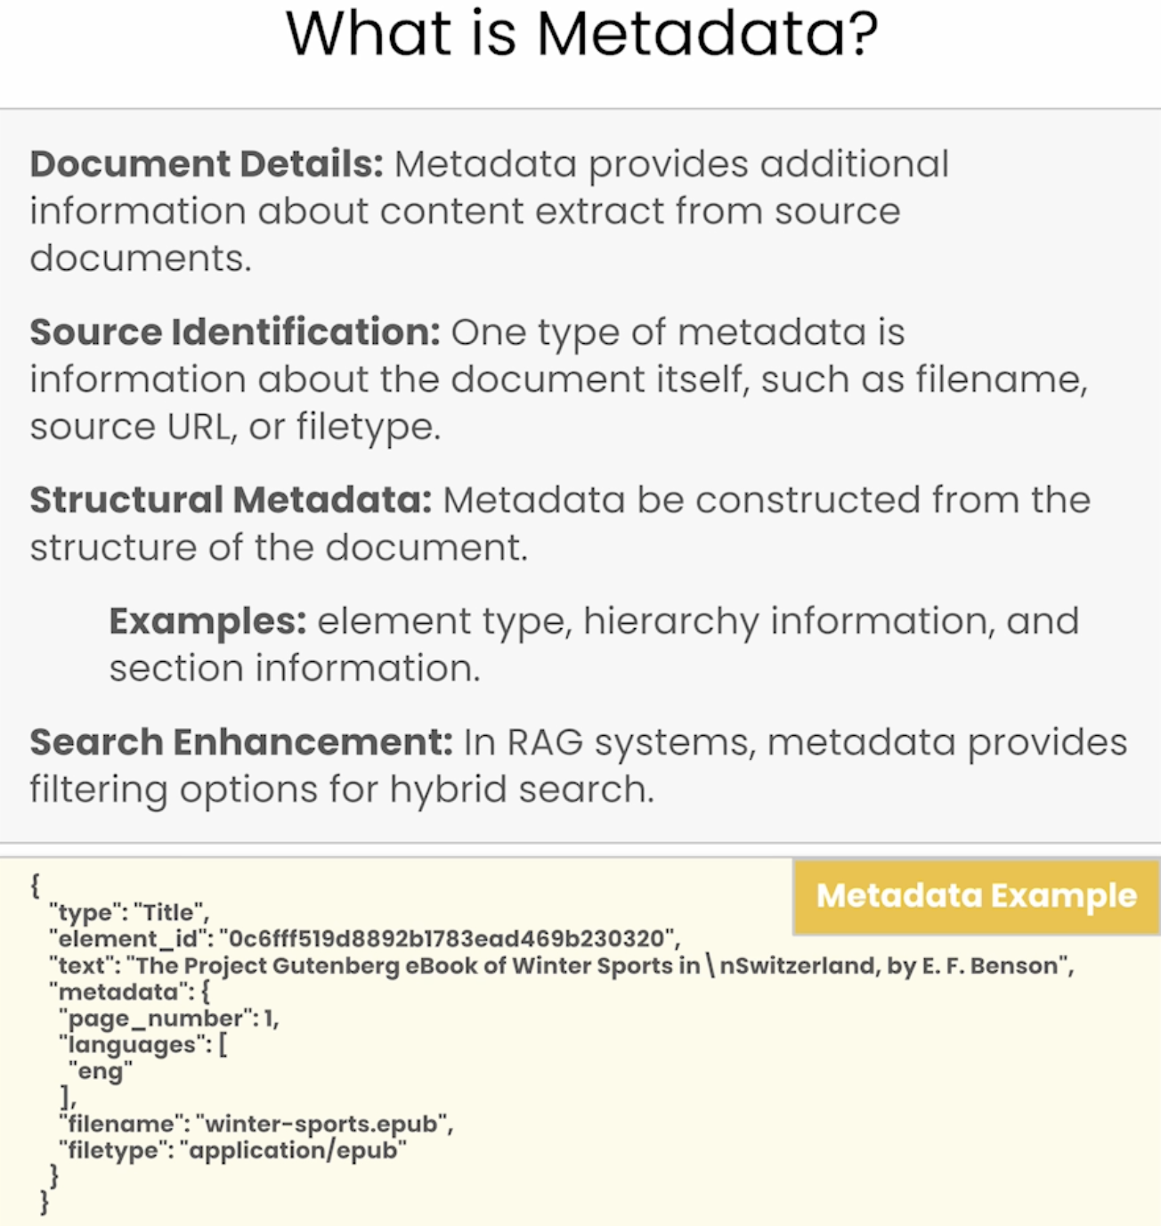

**Semantic Search for LLMs**

**Busca documentos basándose en el significado** del texto, no solo en palabras exactas.

* Convierte los textos (consulta y documentos) a **vectores numéricos** usando **embeddings**.
* Usa **cosine similarity** (u otra métrica) para encontrar los textos **más parecidos semánticamente**, aunque no compartan palabras exactas.

Ejemplo:

**Consulta:** “Cómo encontrar documentos parecidos con IA”

**Resultado:**

* “Semantic search para recuperación de información con LLMs”
* “Uso de embeddings para comparar textos similares”

Aquí no hace falta que aparezcan palabras exactas como "encontrar" o "documentos", porque se basa en significado.

*Semantic Search with Vector Databases*

**Goal:** Given an input text, find semantically similar content from a corpus of documents for use in prompt templates.

**Embedding:** Convert text to vectors that can be compared through a similarity function, such as cosine similarity.

**Vector Database:** A database optimized for performing similarity search.

**Prompt Templating: I**nsert relevant content into a template to generate a prompt for the LLM. Often content semantically similar to an input query.

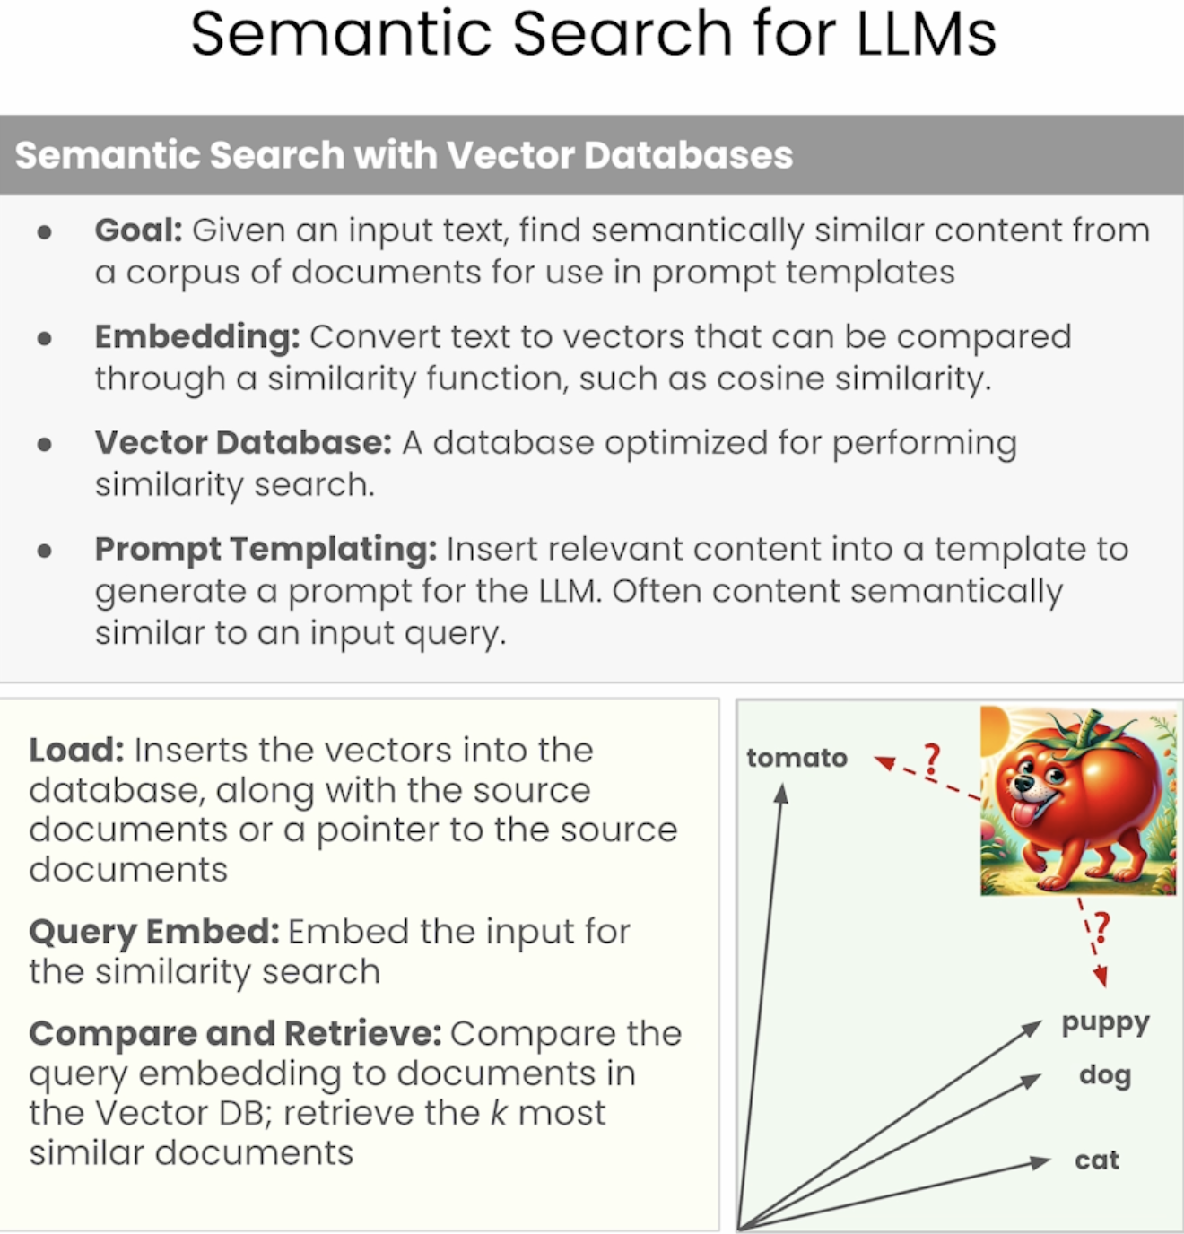

**Hybrid search**

**Combina semantic search con técnicas tradicionales** como búsqueda por palabras clave, filtros o ranking.

🔧 Qué agrega:

* **Palabras clave**: busca coincidencias exactas además del significado.
* **Filtros**: permite restringir por fechas, categorías, autores, etc.
* **Ránkings**: prioriza documentos más recientes o más relevantes.

✅ Ejemplo:

**Consulta:** “Novedades sobre búsqueda semántica en 2024”

* Semantic search encuentra textos sobre “semantic search” sin importar la fecha.
* **Hybrid search** **filtra** para mostrarte **solo los más recientes** o con una etiqueta como "year": 2024.

*Semantic Similarity Search Challenges*

* ﻿﻿**Too Many Matches:** In cases with a large number of documents, too many semantically similar matches
* ﻿﻿**Most Recent Information:** Users may want the most recent information, not just the most semantically similar
* ﻿﻿**Loss of important information:** Loss of important information within the document that's relevant to the search, such as section information

**Hybrid Strategy:** Hybrid search is a search strategy that combines semantic search with other information retrieval techniques, such as filtering and keyword search.

**Filtering Options:** Metadata from documents provides filtering options for hybrid search.

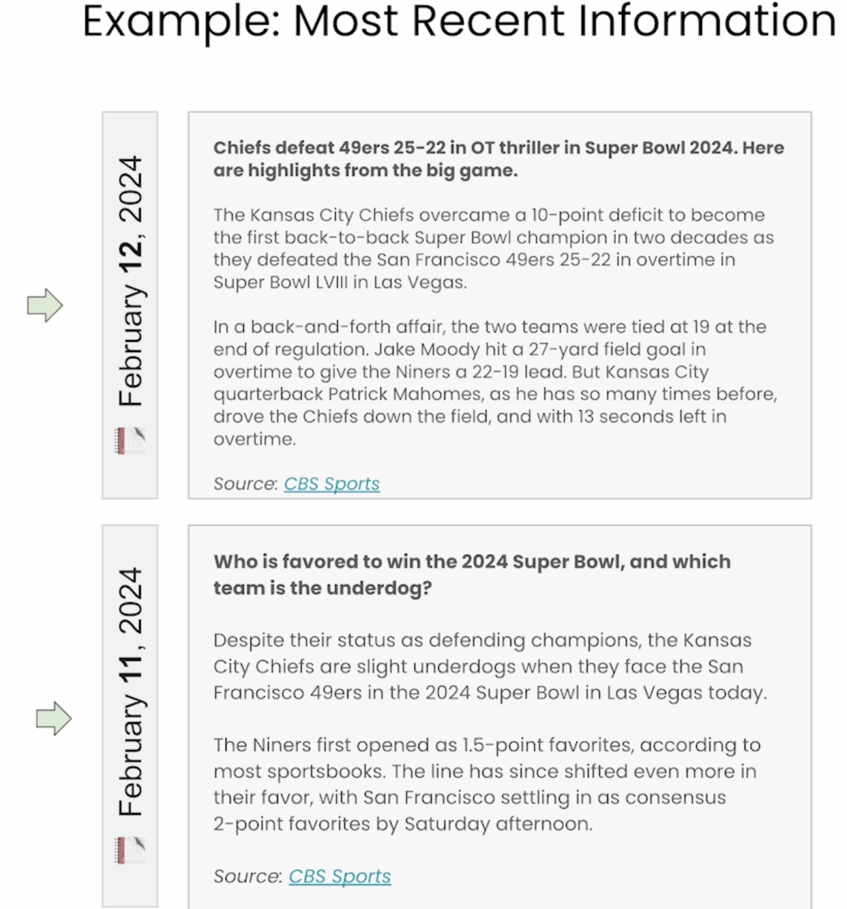

# Warning control

import warnings

warnings.filterwarnings('ignore')

import logging

logger = logging.getLogger()

logger.setLevel(logging.CRITICAL)

import json

from IPython.display import JSON

from unstructured_client import UnstructuredClient

from unstructured_client.models import shared

from unstructured_client.models.errors import SDKError

from unstructured.chunking.basic import chunk_elements

from unstructured.chunking.title import chunk_by_title

from unstructured.staging.base import dict_to_elements

import chromadb # *chromadb is an in-memory vector database that in this lesson you will use to conduct your similarity search*

from Utils import Utils

utils = Utils()

DLAI_API_KEY = utils.get_dlai_api_key()

DLAI_API_URL = utils.get_dlai_url()

s = UnstructuredClient(

api_key_auth=DLAI_API_KEY,

server_url=DLAI_API_URL,

)

In this case you are going to use the unstructured api instead of the open source library because in this case e-publications get converted to HTML before pre-processing.

**Chunking**

**Chunking Necessity:** Vector databases need documents split into chunks for retrieval and prompt generation.

**Query Result Variability:** The same query will return different content depending on how the document is chunked.

**Even Size Chunks:** The easiest way is to split the document into roughly even size chunks. This can result in similar content getting split across chunks.

**Chunking by Atomic Elements:** By identifying atomic elements, you can chunk by combining elements rather than splitting raw text.

* ﻿﻿Results in more coherent chunks
* ﻿﻿Example: combining content under the same section header into the same chunk.

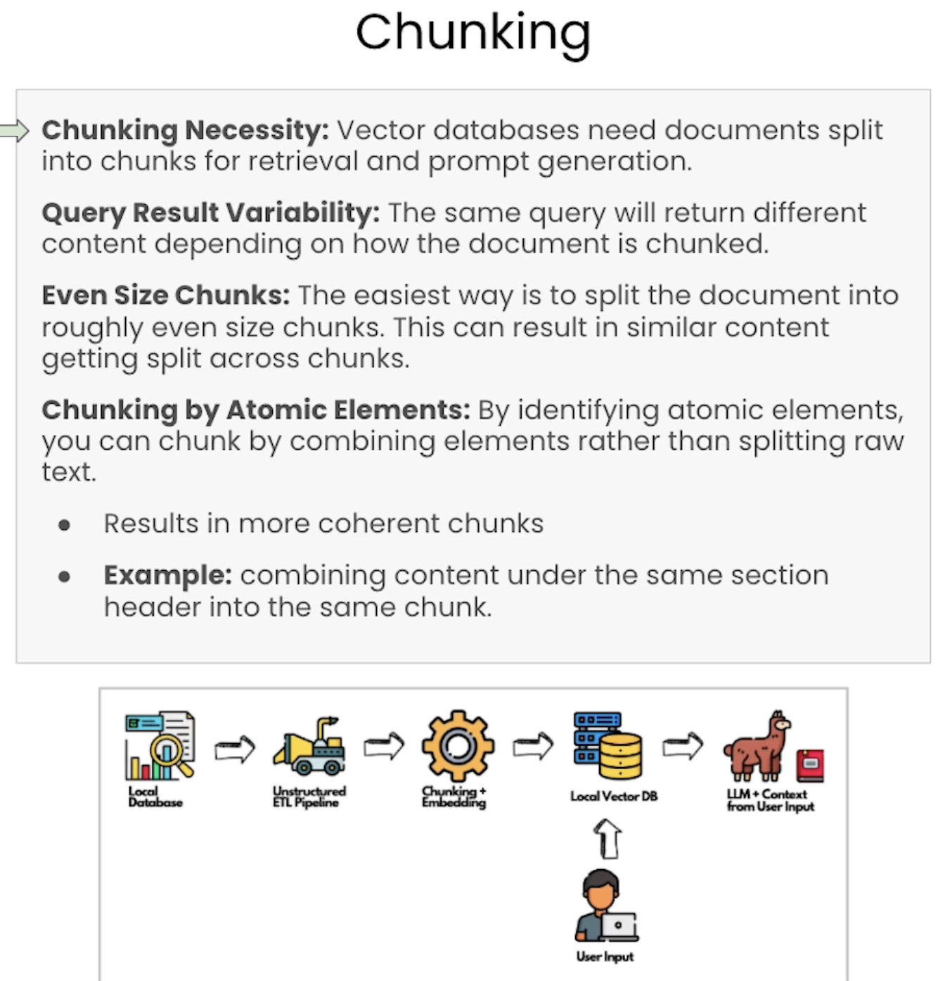

**Chunking From Elements**

*Constructing Chunks from Document Elements*

**Partitioning:** First, break the document down into atomic elements, as described in Lesson 1.

**Combine Elements into Chunks:** Add one document element to the chunk. Continue adding document elements to the chunk until you've reached a character or token threshold.

**Apply Break Conditions:** Apply a condition for starting a new chunk, such as when we reach a new title element (indicating a new section), when element metadata changes (indicating a new page or section), or when content similarity exceeds a threshold.

Basic combinative chunking applies no break conditions.

**Combine Smaller Chunks:** Optionally, combine small chunks so chunks are sufficiently large for effective semantic searches.

**Coherent Chunks:** Keeps content from the same document element together, resulting in more coherent chunks.

**Structured Chunks:** Allows the chunking method to take advantage of the document structure, which is not the case for traditional chunking techniques that split on token or character count.

**Rapid Experimentation:** Building chunks from document elements allows for rapid experimentation (partitioning is expensive, chunking is fast).

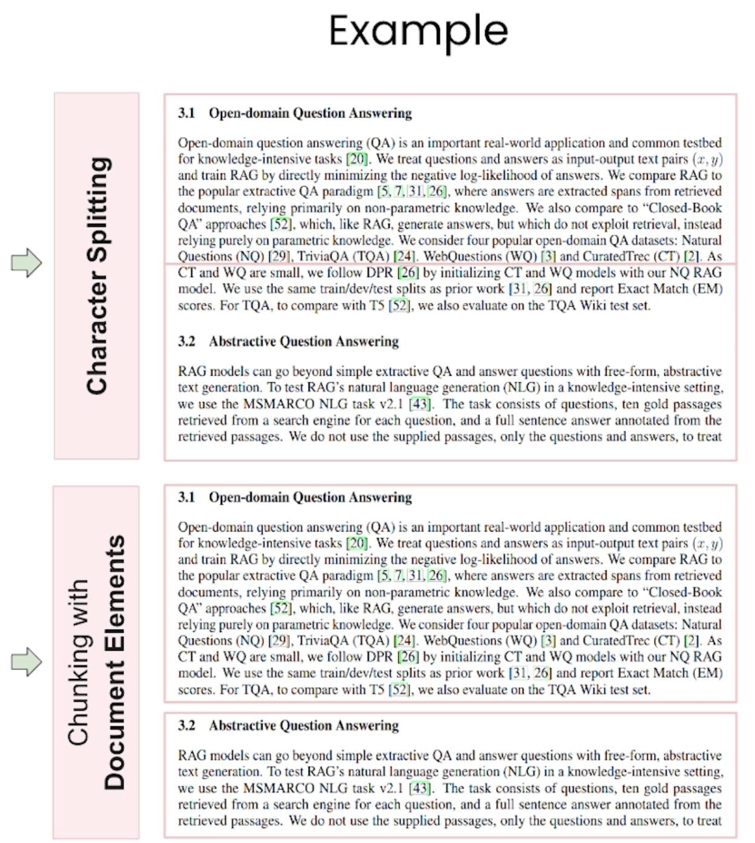

## **Preprocessing PDFs and Images**

*Document Image Analysis (DIA)*

**DIA** es el proceso de **analizar documentos visuales** (como PDFs o imágenes escaneadas) para:

* **Detectar la estructura del documento**
* **Extraer texto e información visual**

**Preprocessing with Rules-based Parsers:** Many document types, such as HTML, Word Docs, and Markdown include formatting information. These documents can be preprocessed with rules-based parsers.

**Visual Information:** For other documents, such as PDFS and images, the formatting information is visual.

**Document Image Analysis (DIA)** allows us to extract formatting information and text from the raw image of a document.

**DIA Methods**

You will learn two techniques today: **1) Document Layout Detection** and **2) Vision Transformers.**

* ﻿﻿Document Layout Detection (**DLD**) uses an object detection model to draw and label bounding boxes around layout elements on a document image.
* ﻿﻿Vision Transformer (**ViT**) models take a document image as input and produce a text representation of a structured output (like JSON) as output.

Note: ViTs can optionally include a text prompt.

**Document Layout Detection**

**Vision Detection:** Identify and classify bounding box using a computer vision model, such as YOLOX or Detectron2.

**Text Extraction:** Extract text from the bounding box using object character recognition (OCR) when necessary.

**Direct Extraction:** For some documents like PDFs, text can be extracted directly from the document without OCR.

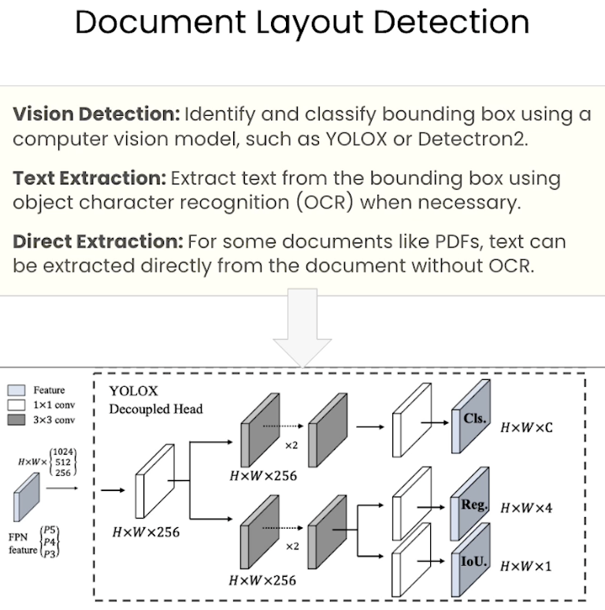

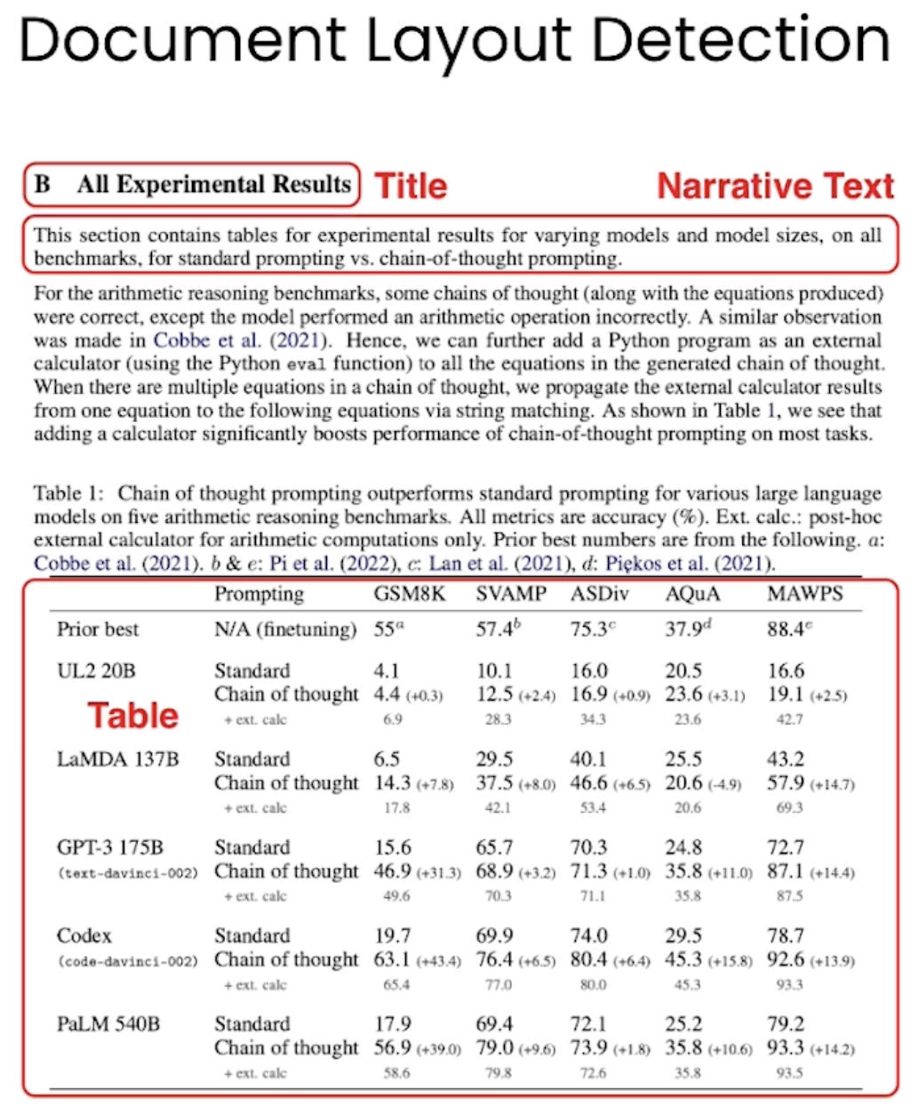

**Vision Transformers**

**Visual Translation:** Input image is passed to the encoder and the decoder produces text output.

**DONUT Architecture:** Document Understanding Transformer (DONUT) is a common architecture.

**Direct Conversion:** OCR is not required - the image input is converted directly to text.

**Structured Training:** Can train the model to output a valid JSON string with the structured document output.

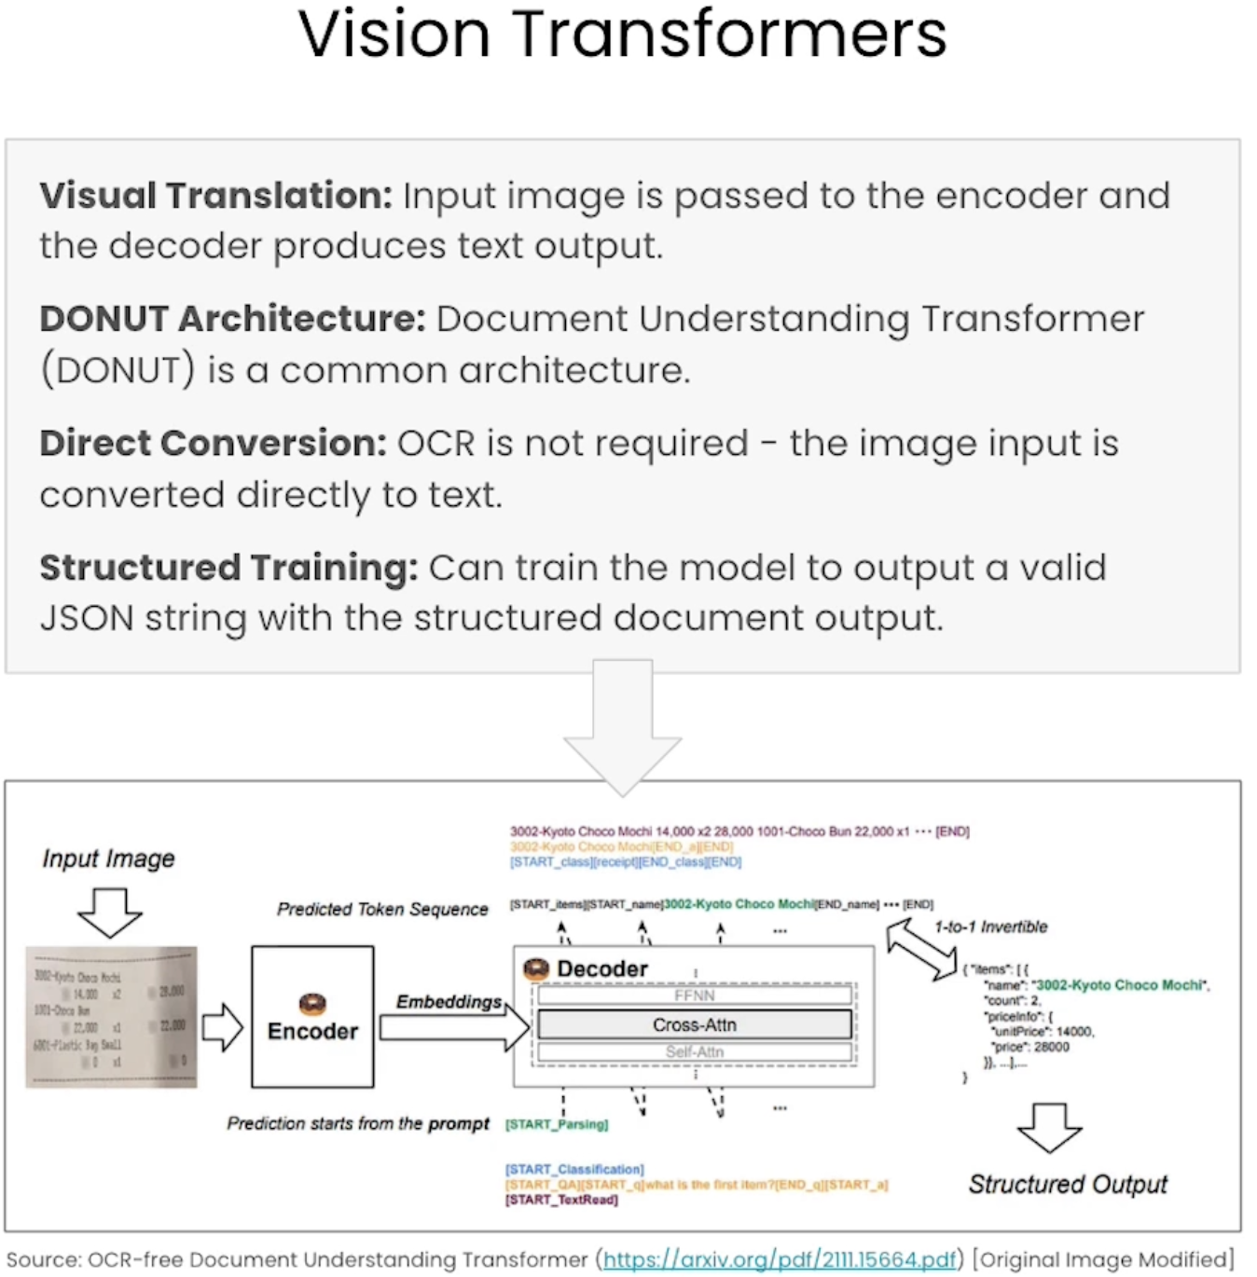

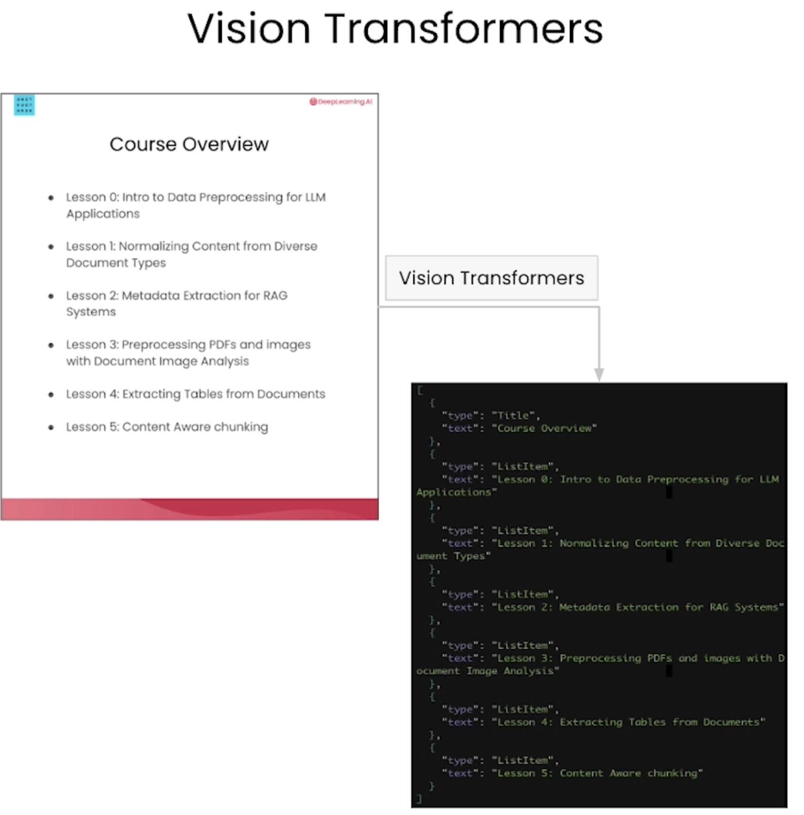

When should I use a vision transformer and when should I use a document layout detection model?

**Advantages & Disadvantages**

*Document Layout Models*

**Advantages**

* ﻿﻿Have a fixed set of element types.
* ﻿﻿Get bounding box information

**Disadvantages**

• Requires two model calls (the object detection and OCR models)

• Less Flexible

*Vision Transformers*

**Advantages**

* ﻿﻿More flexible for non-standard document types, like forms.
* ﻿﻿More adaptable to new ontologies.

**Disadvantages**

* ﻿﻿Model is generative, potentially prone to hallucination or repetition.
* Computationally expensive

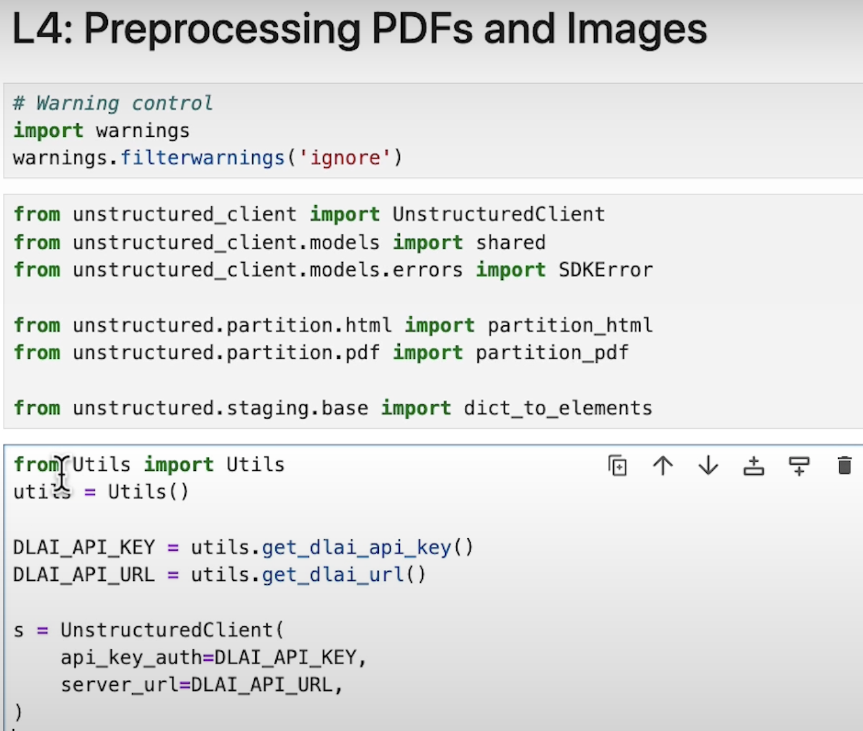

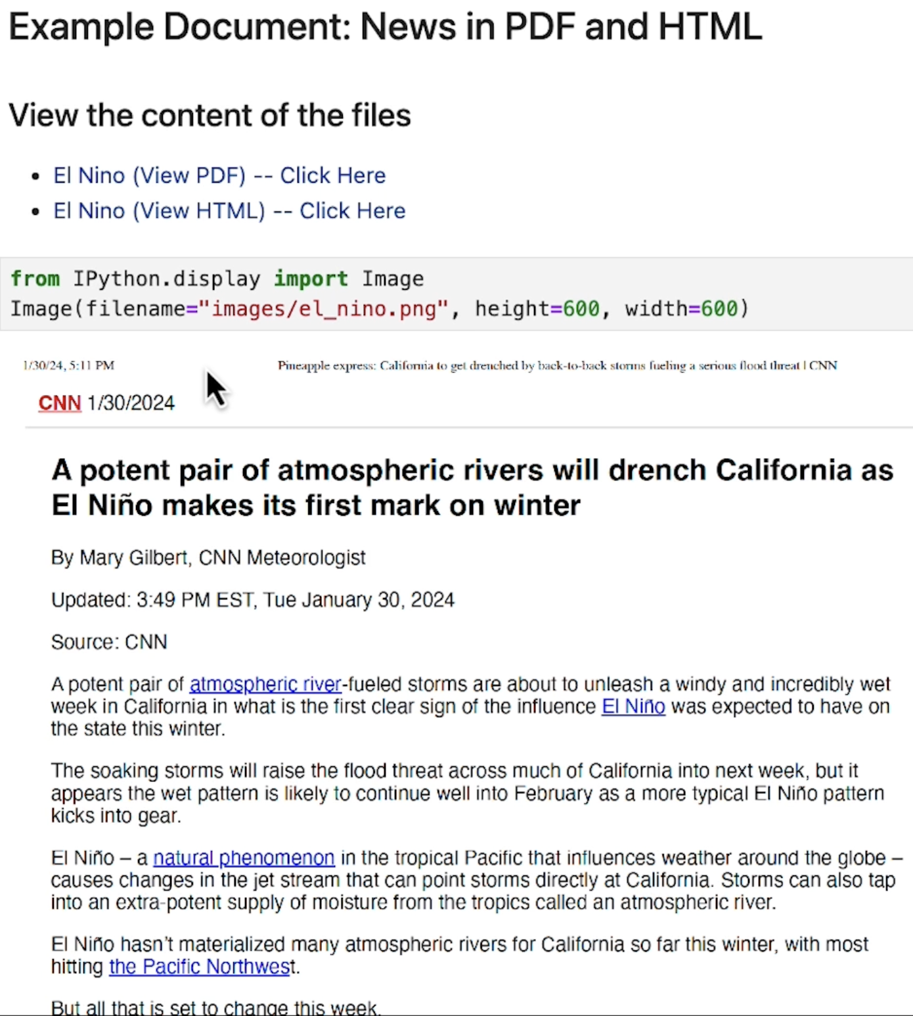

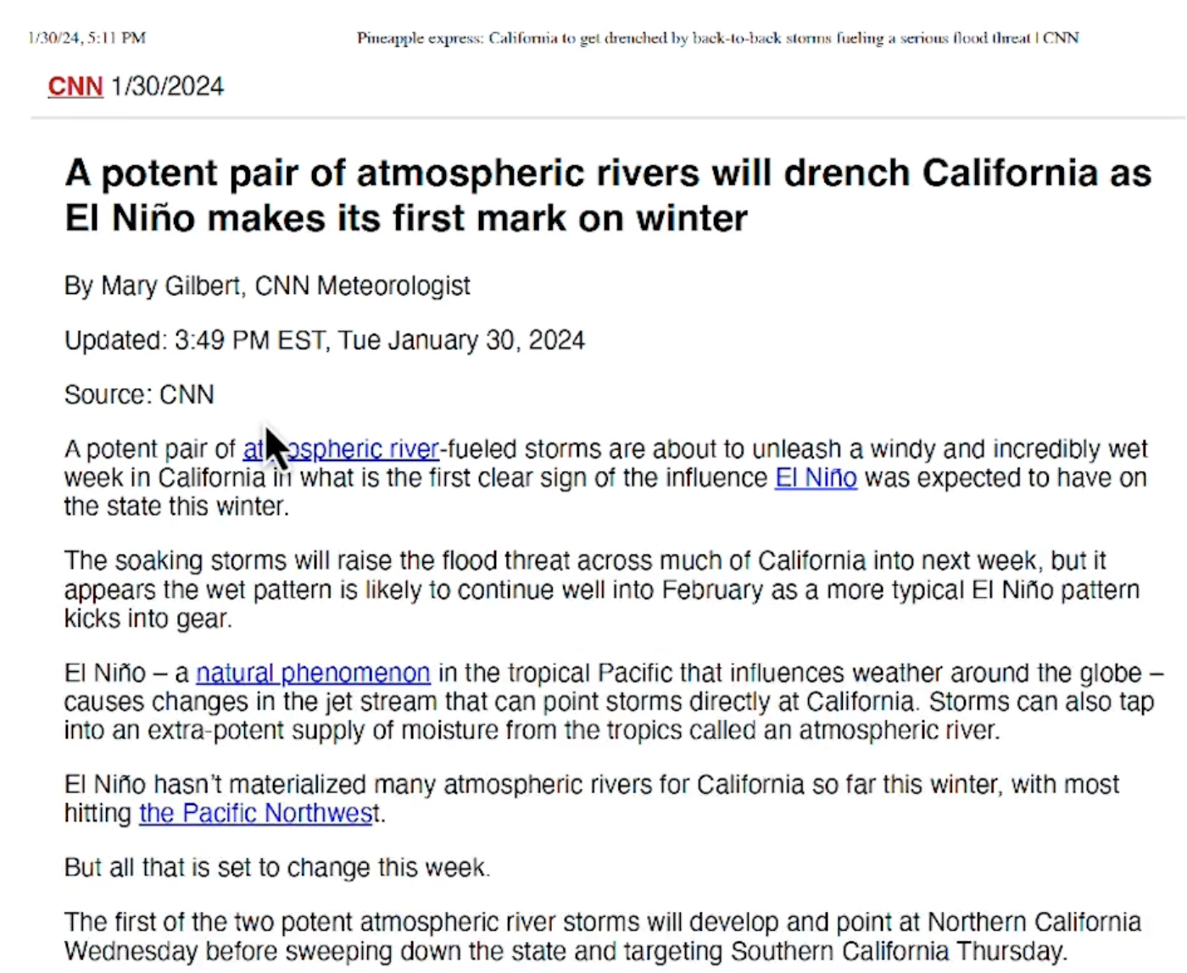

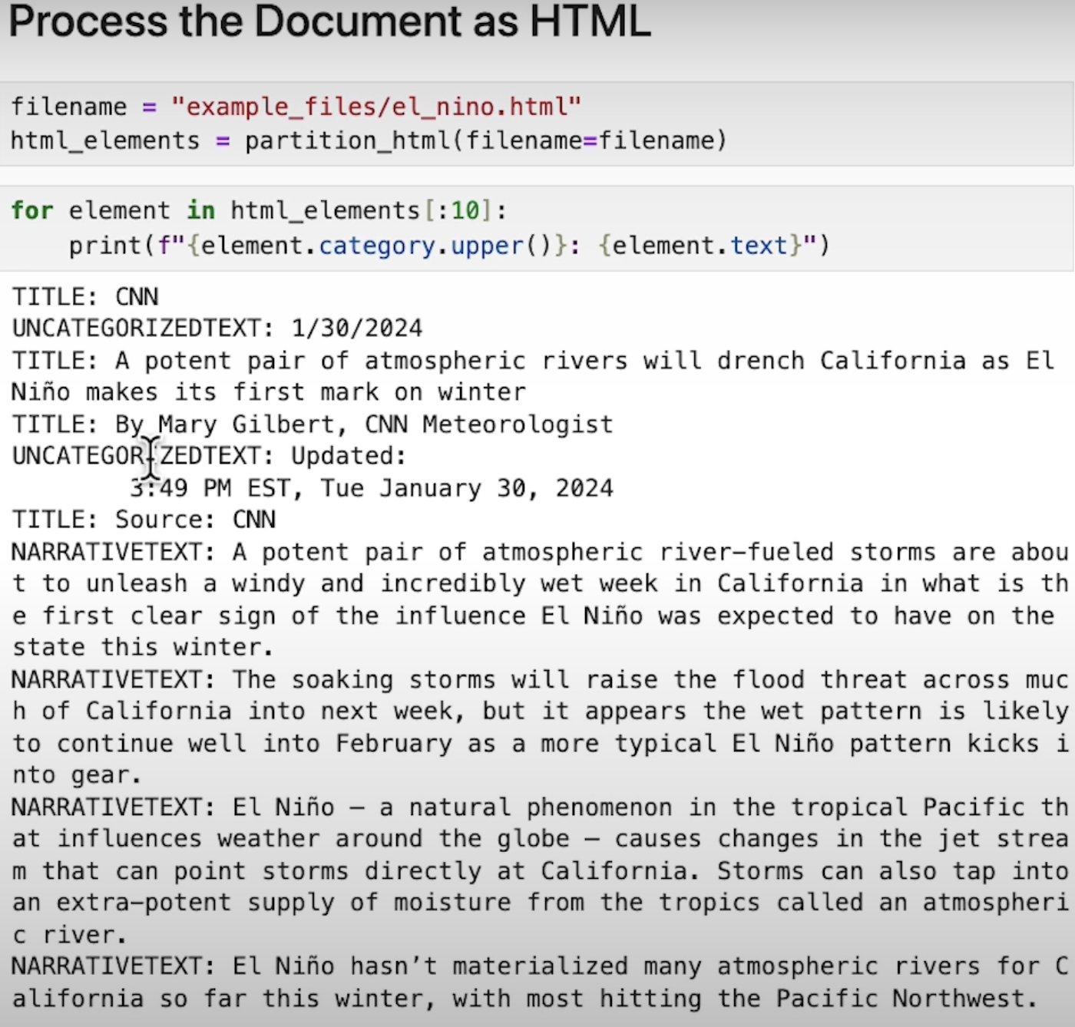

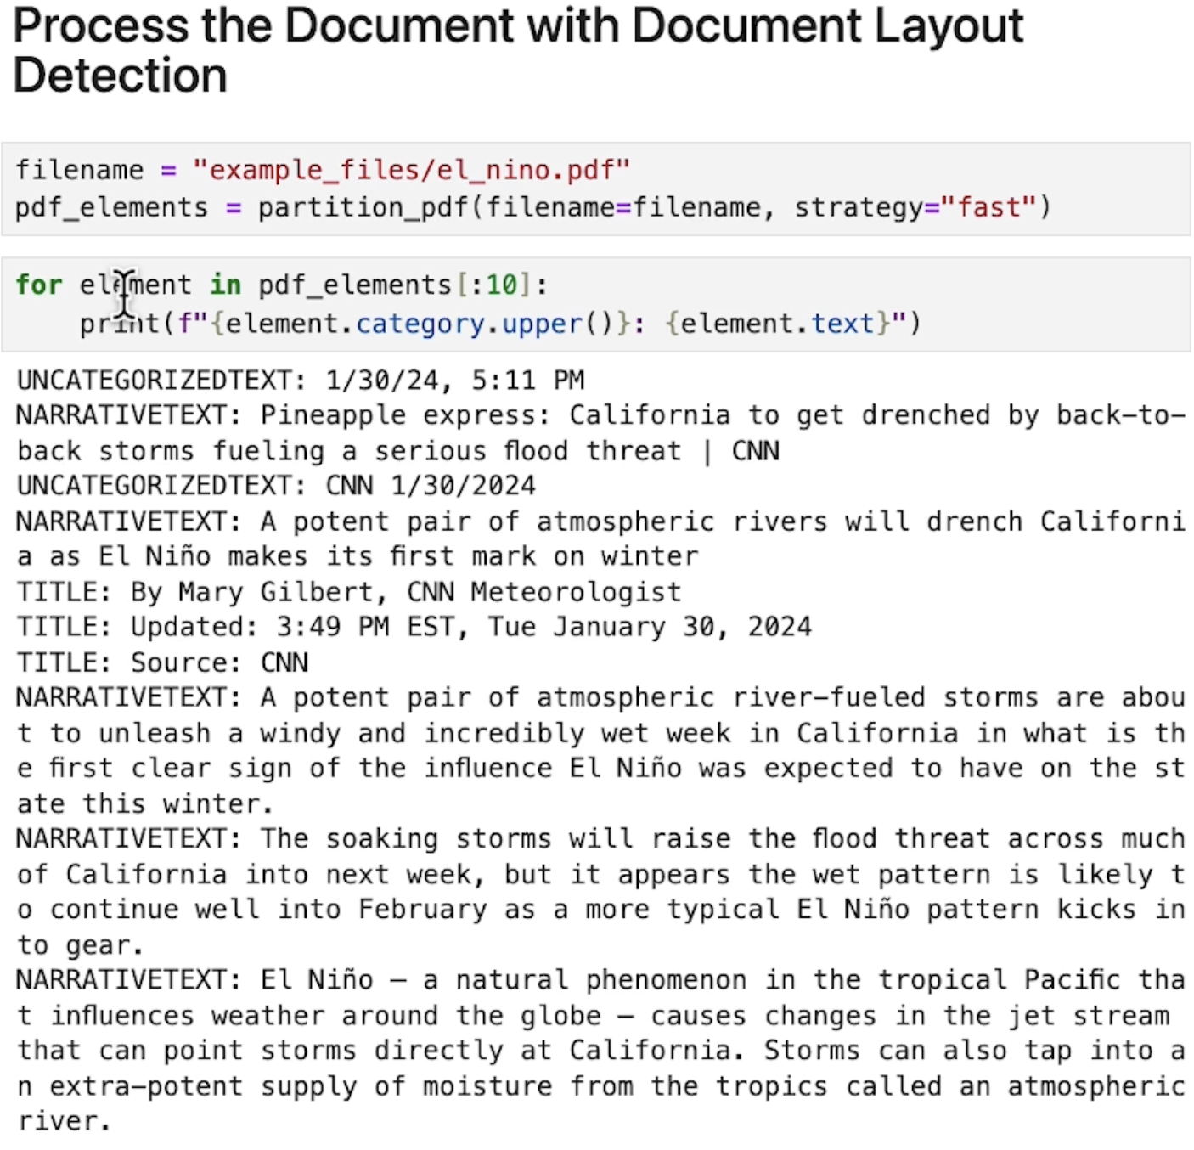

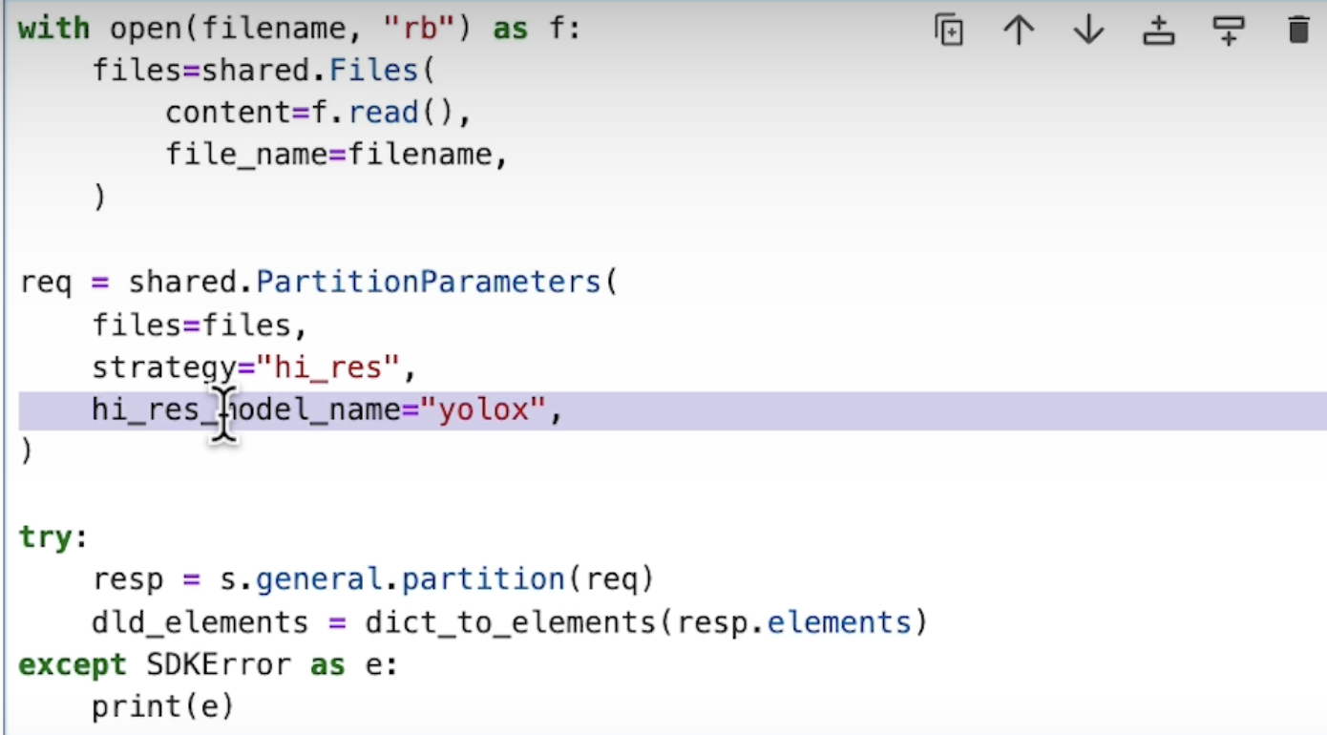

This process could take several seconds.

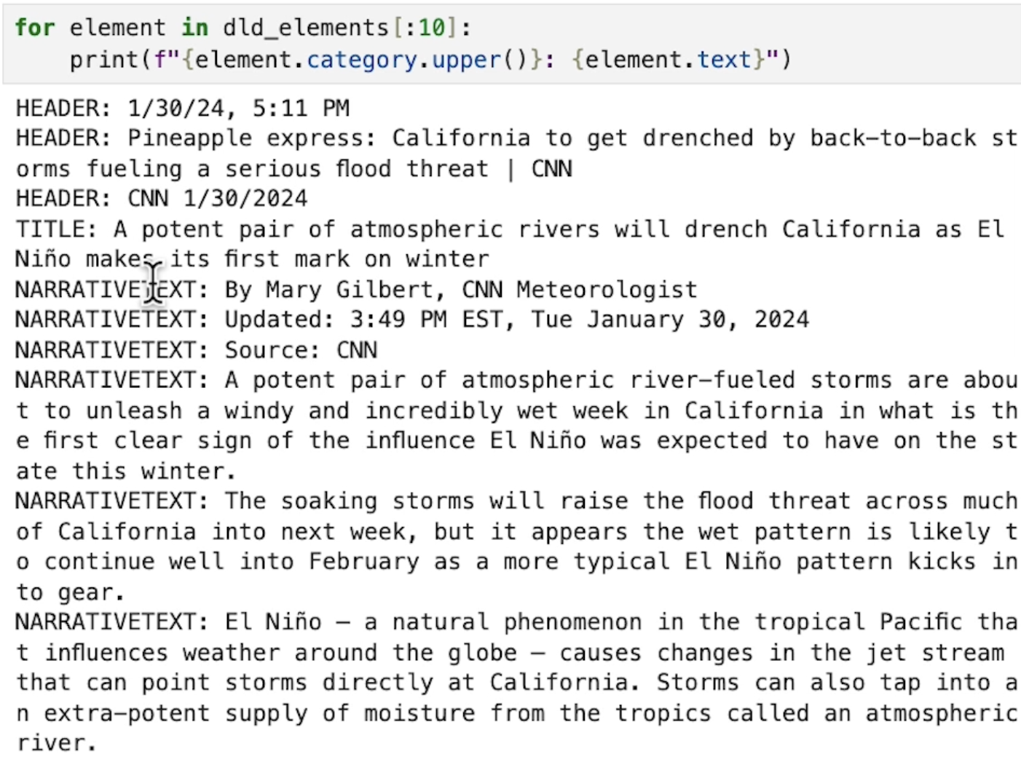

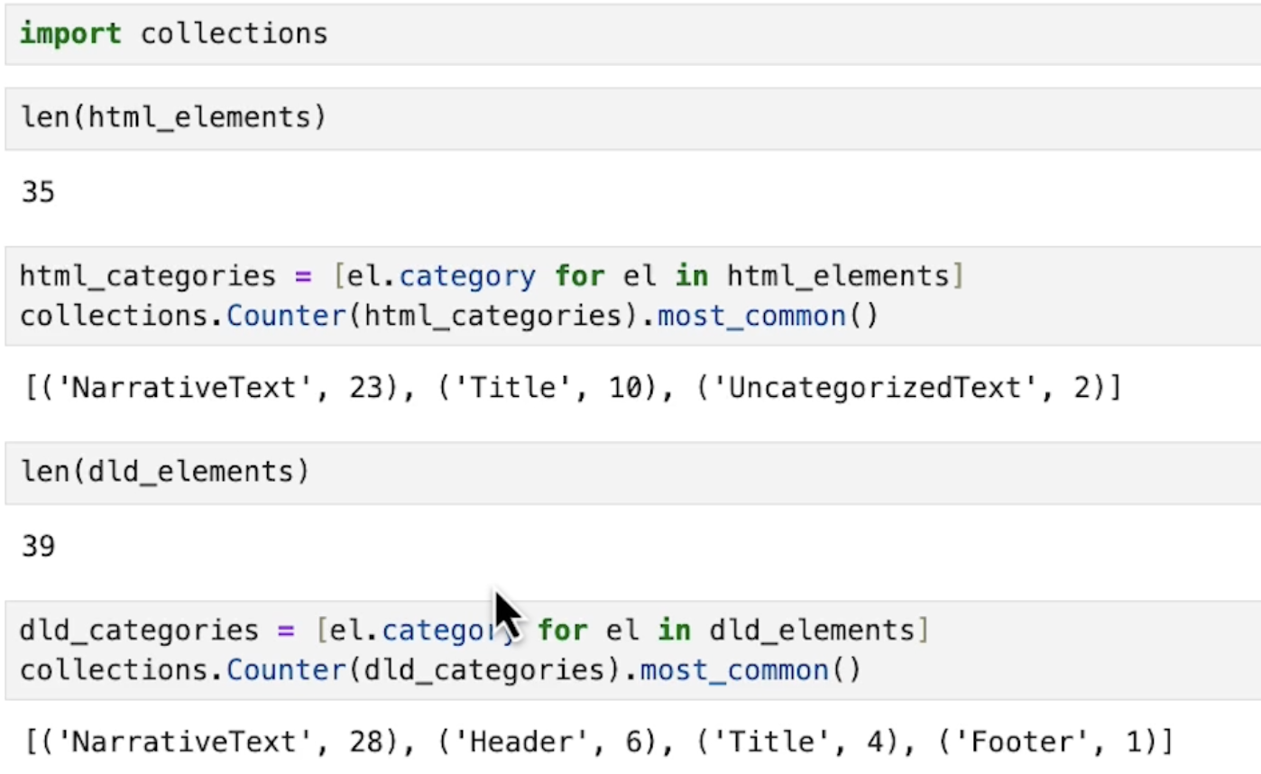

## **Extracting Tables**

Table Extraction

**Text Analysis:** Most RAG use cases focus on text content within documents.

**Structured Data:** Some industries (i.e., finance, insurance) deal heavily with structured data embedded in unstructured documents.

**Table Extraction:** To support use cases such as question answering over tables, it is helpful to extract tables from documents.

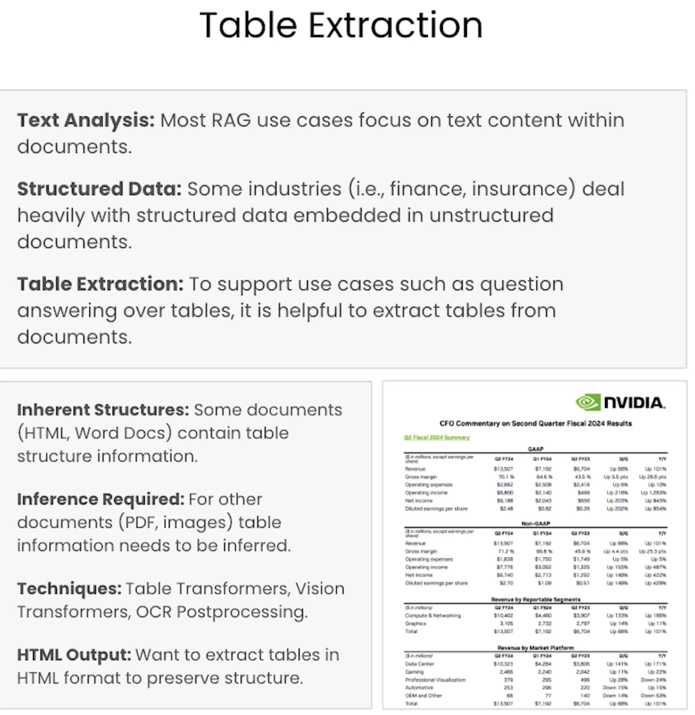

**Table Transformers**

Table transformer is a model that identifies bounding boxes for table cells and converts the output to HTML.

**Two Steps:**

* ﻿﻿﻿First identify tables using the document layout model.
* ﻿﻿﻿then run the table through the table transformer

**Advantages:** can trace cells back to the original bounding boxes.

**Disadvantages:** multiple expensive model calls

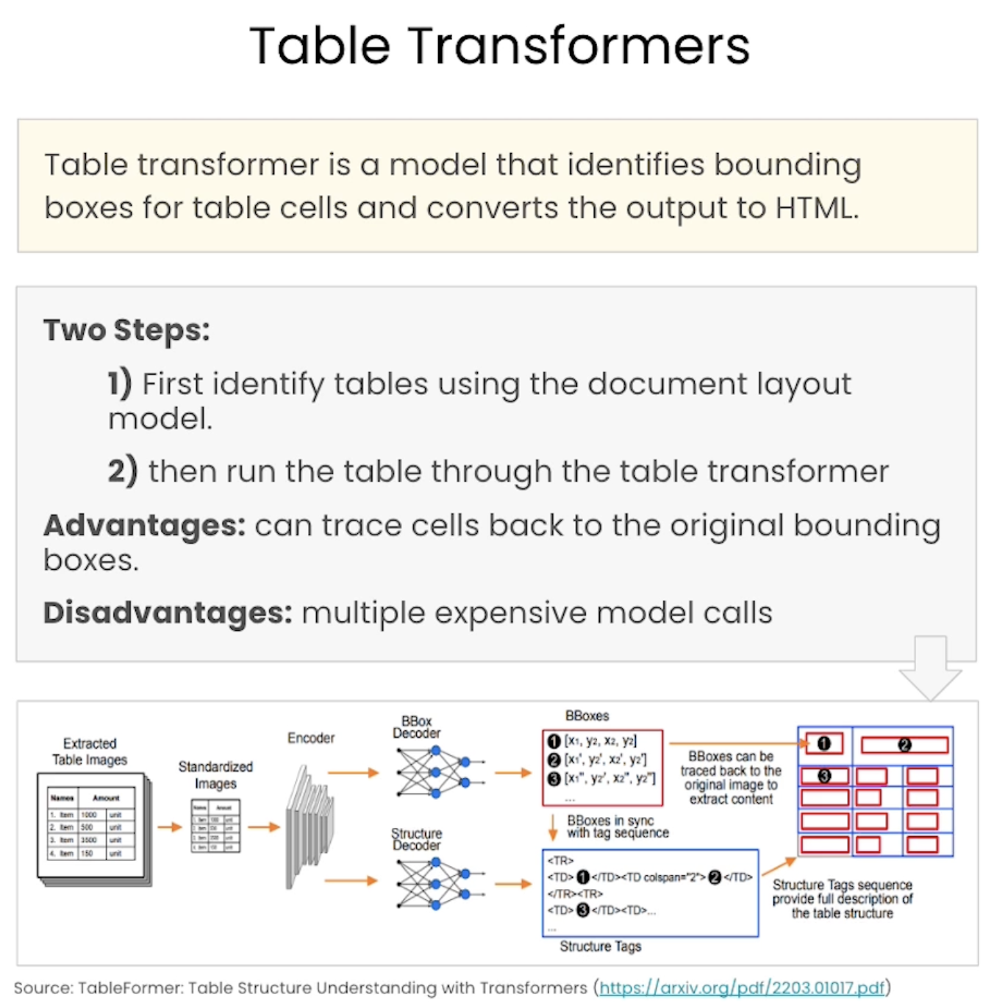

**Vision Transformers**

Use the vision transformer models from previous lesson (Preprocessing PDFs and images), but target HTML as output.

**Advantage:** allows for prompting; more flexible; one model call

**Disadvantage:** generative and prone to hallucination; no bounding boxes

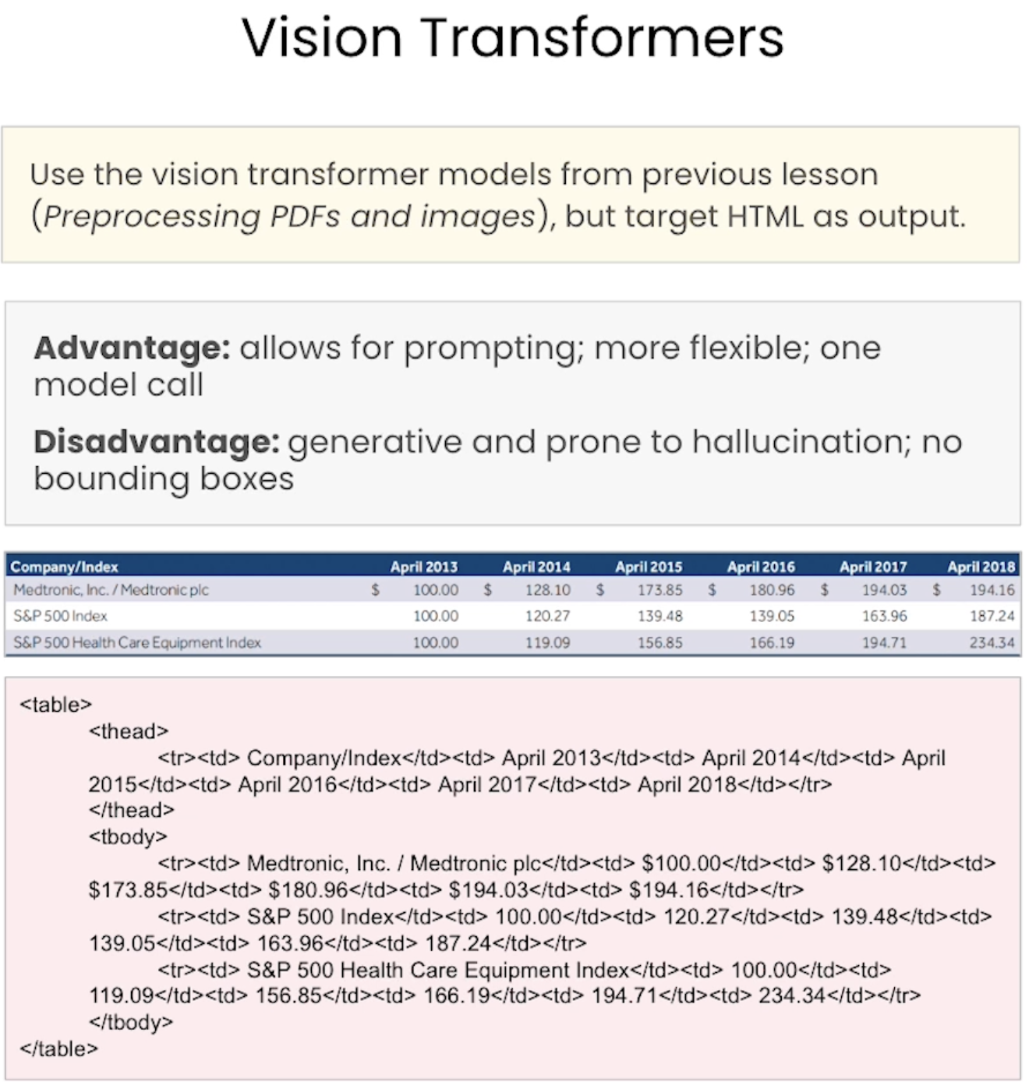

OCR Postprocessing

OCR the table, then build the table structure based on patterns in the OCR output.

**Advantages:** fast; accurate for well-behaved tables

**Disadvantages:** requires statistical or rules-based parsing; less flexible than other approaches; no link back to bounding boxes in image

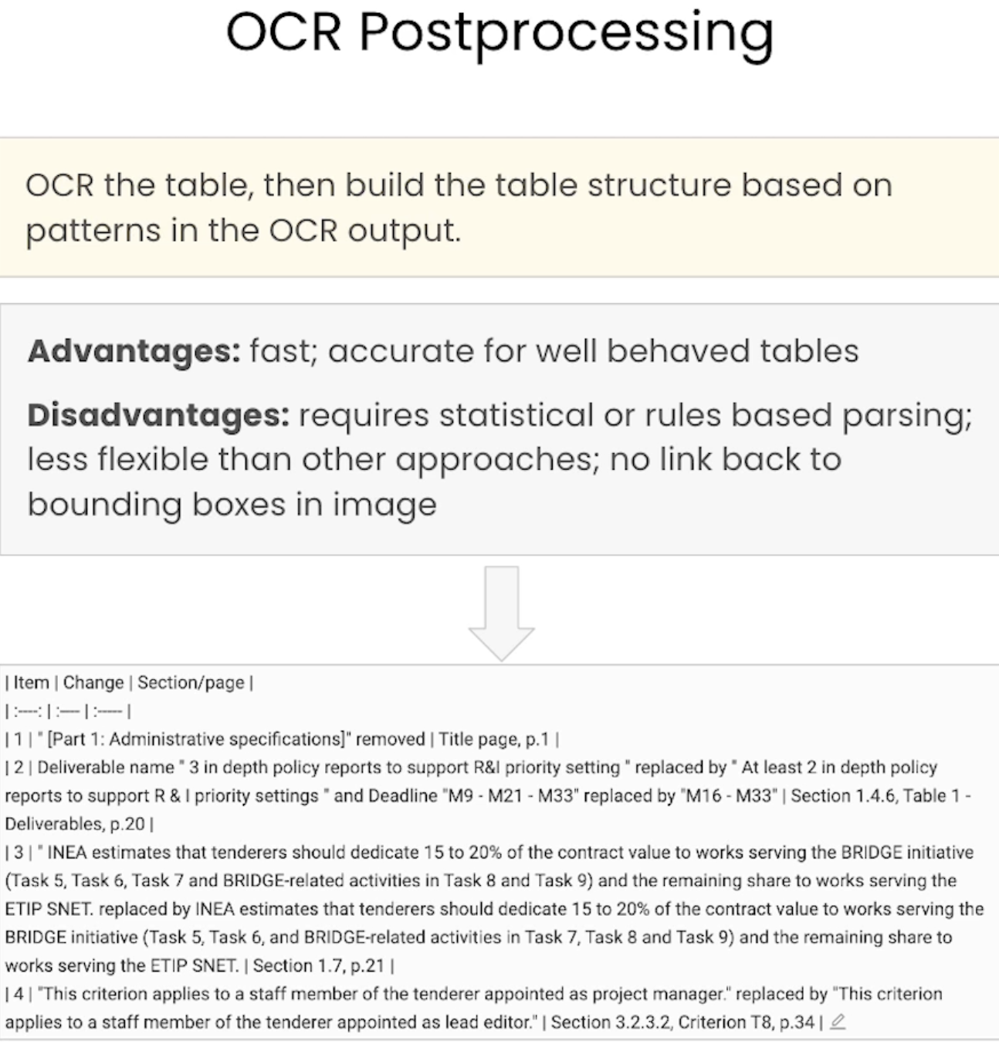

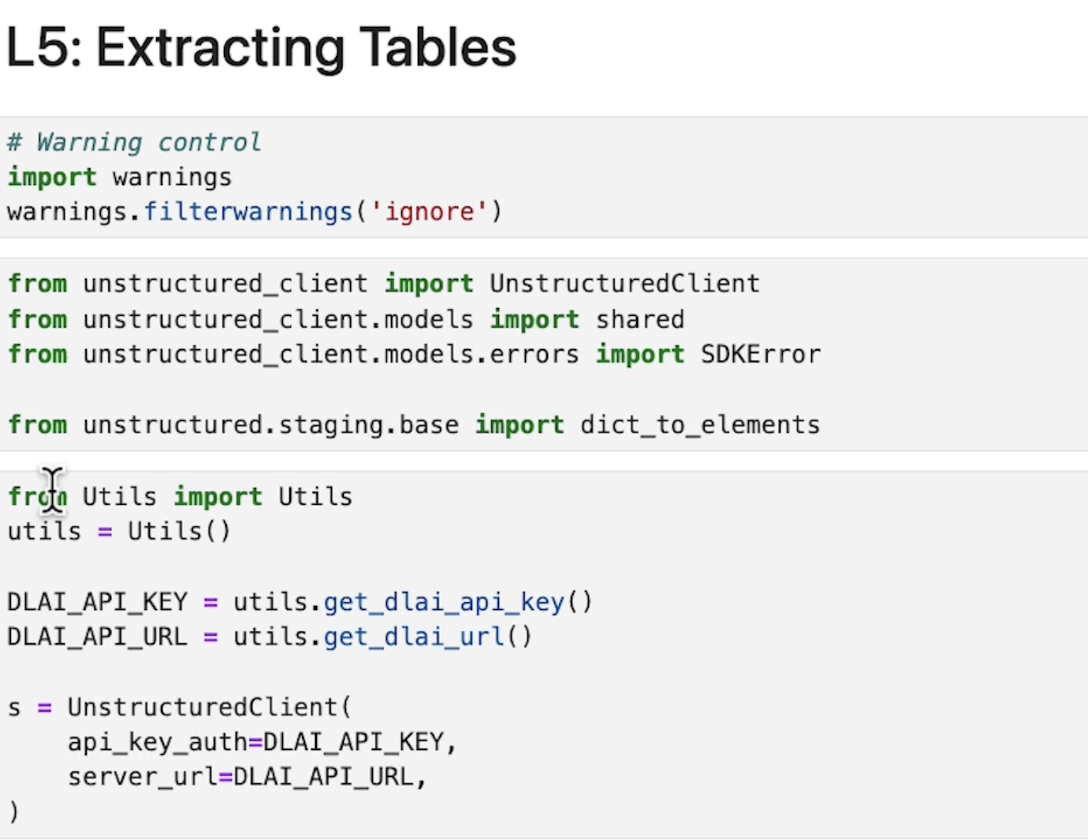

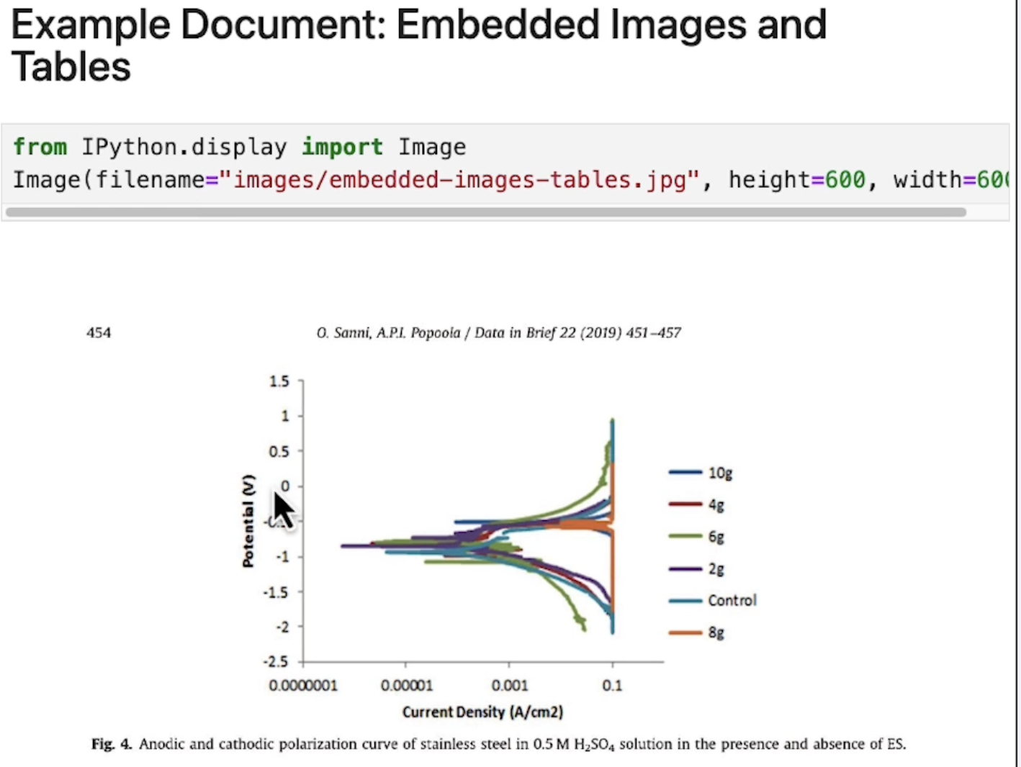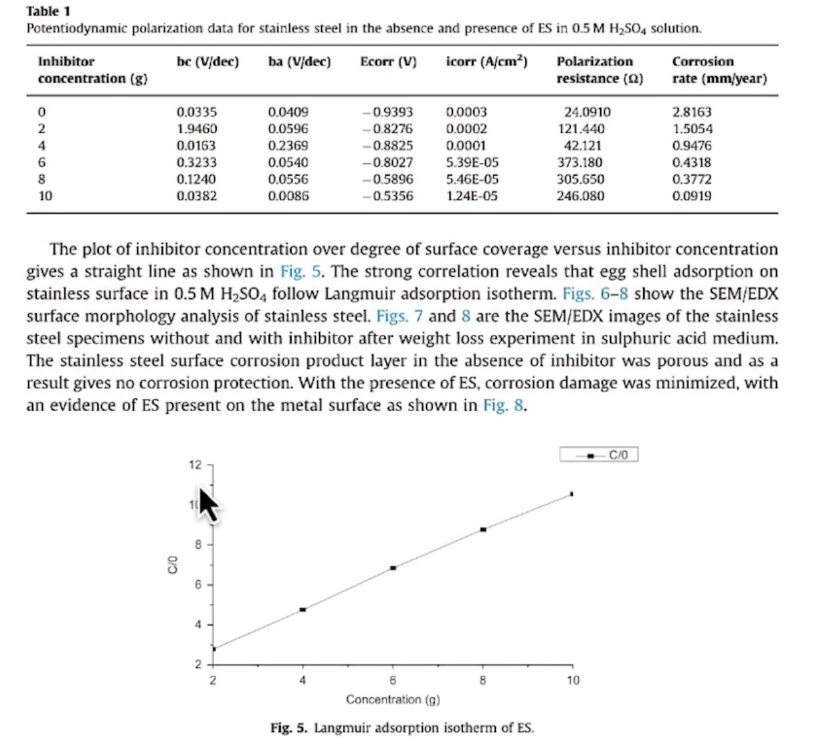

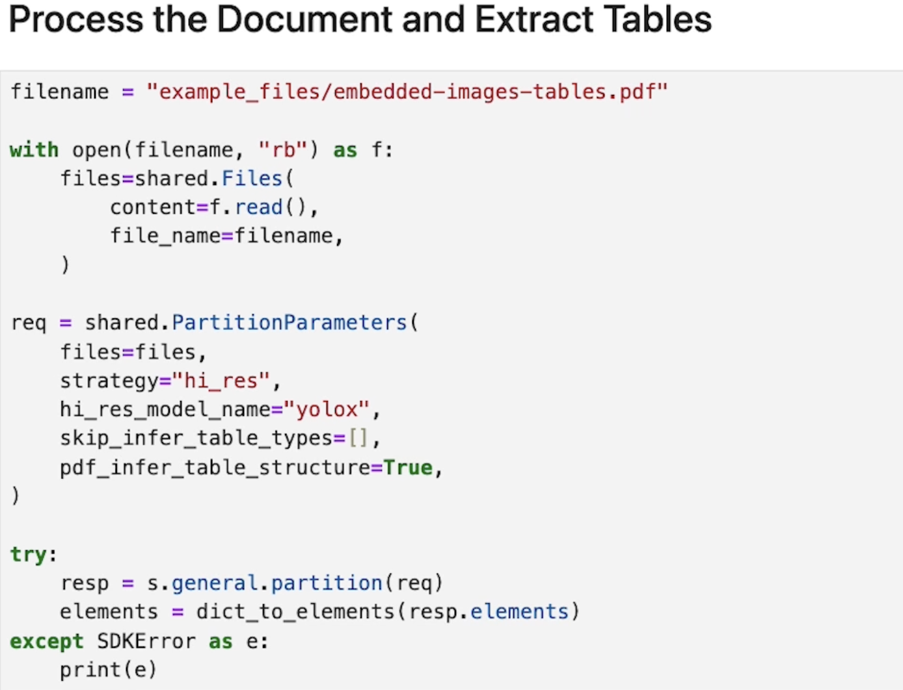

It could take several seconds.

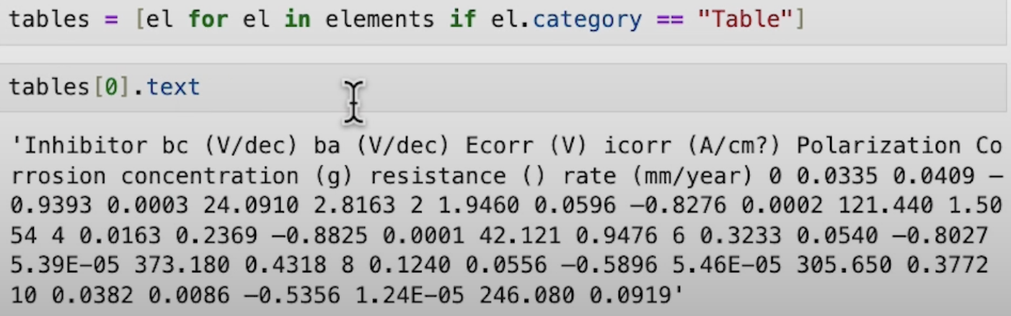

table_html = tables[0].metadata.text_as_html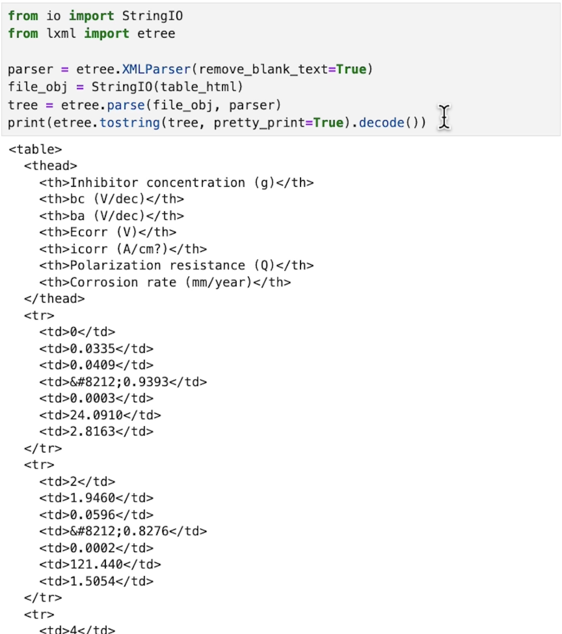

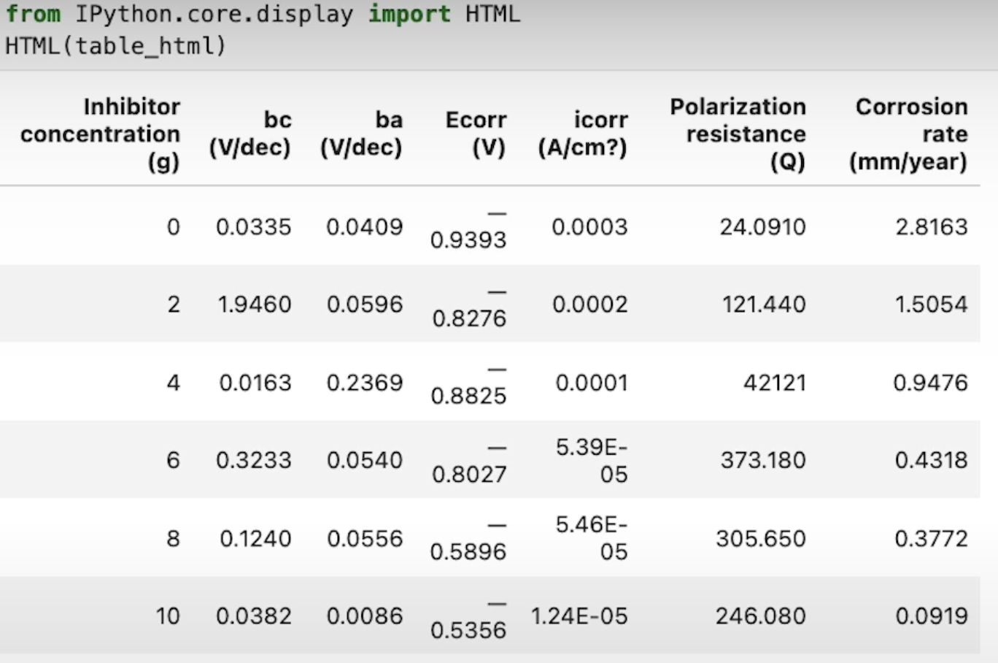

We probably want to summarize the table, so we could use langchain:

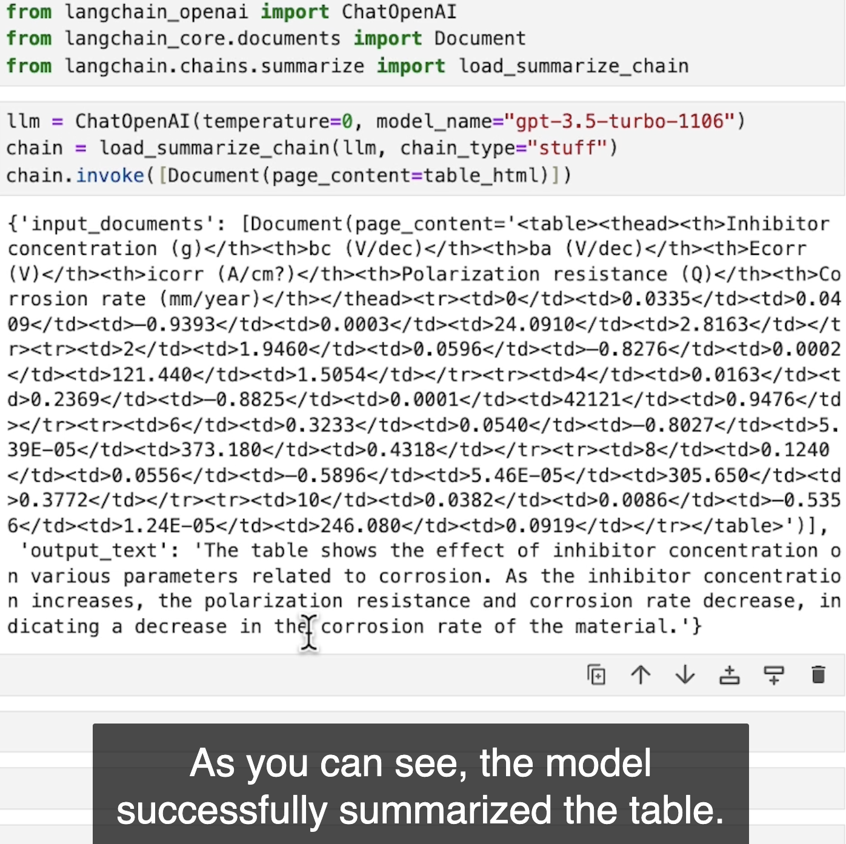

## Build your own RAG

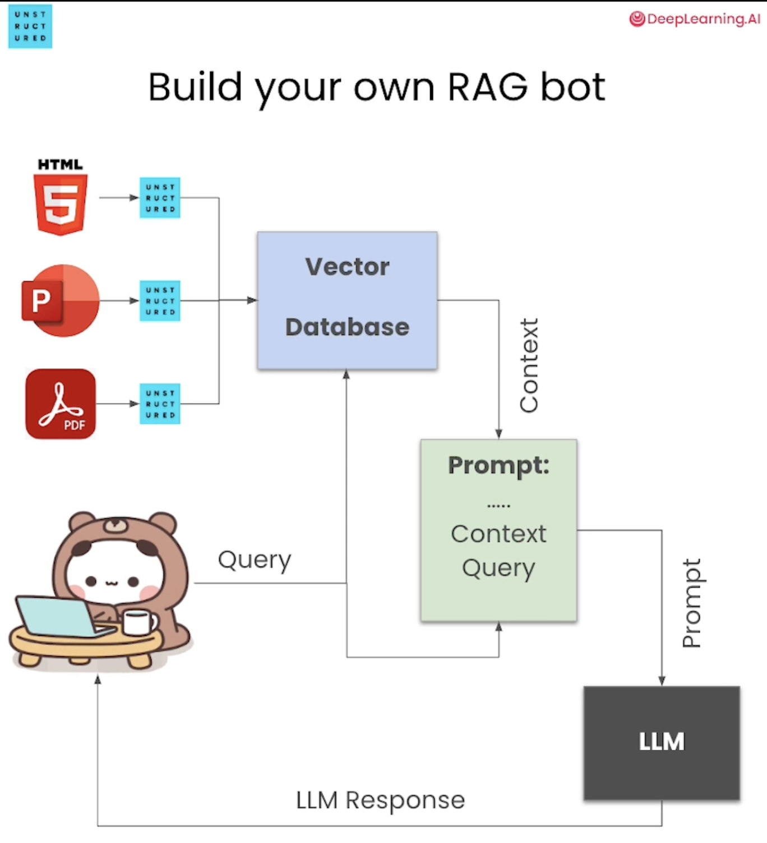

Example:  
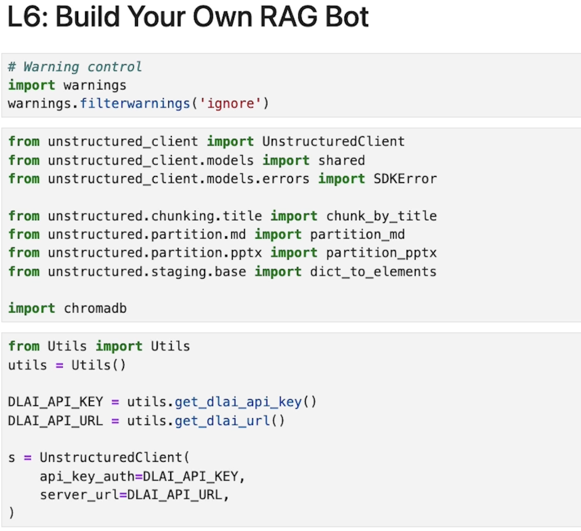 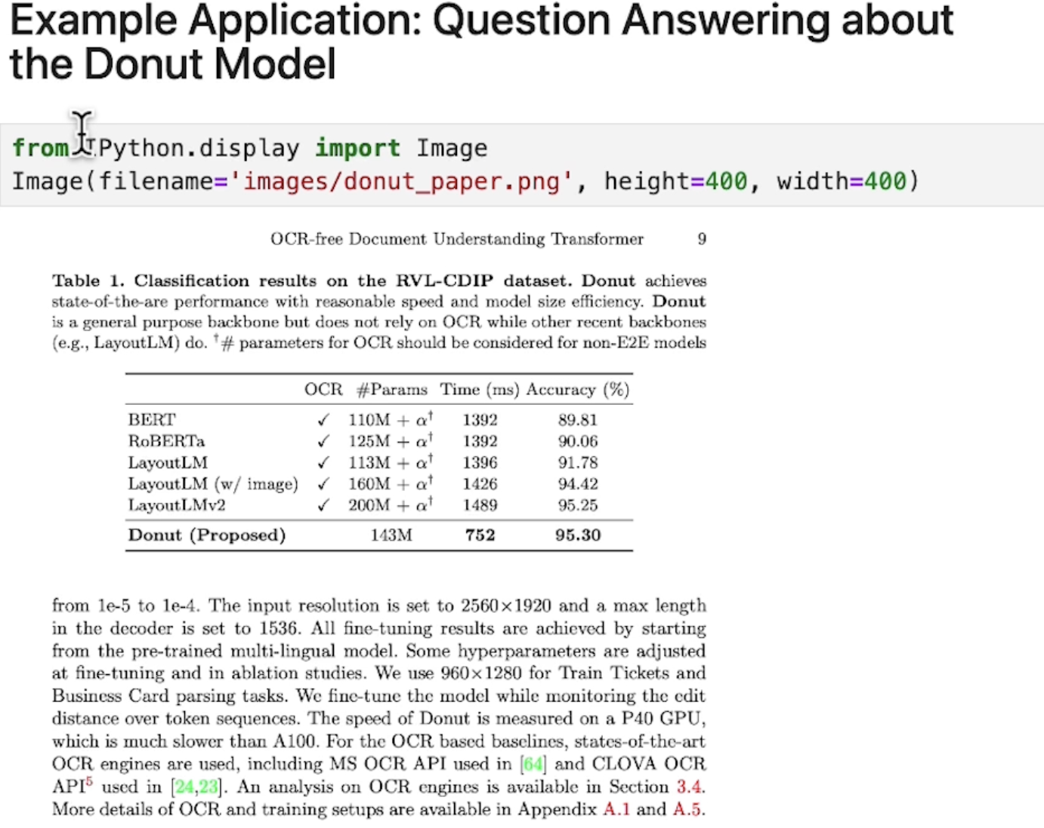 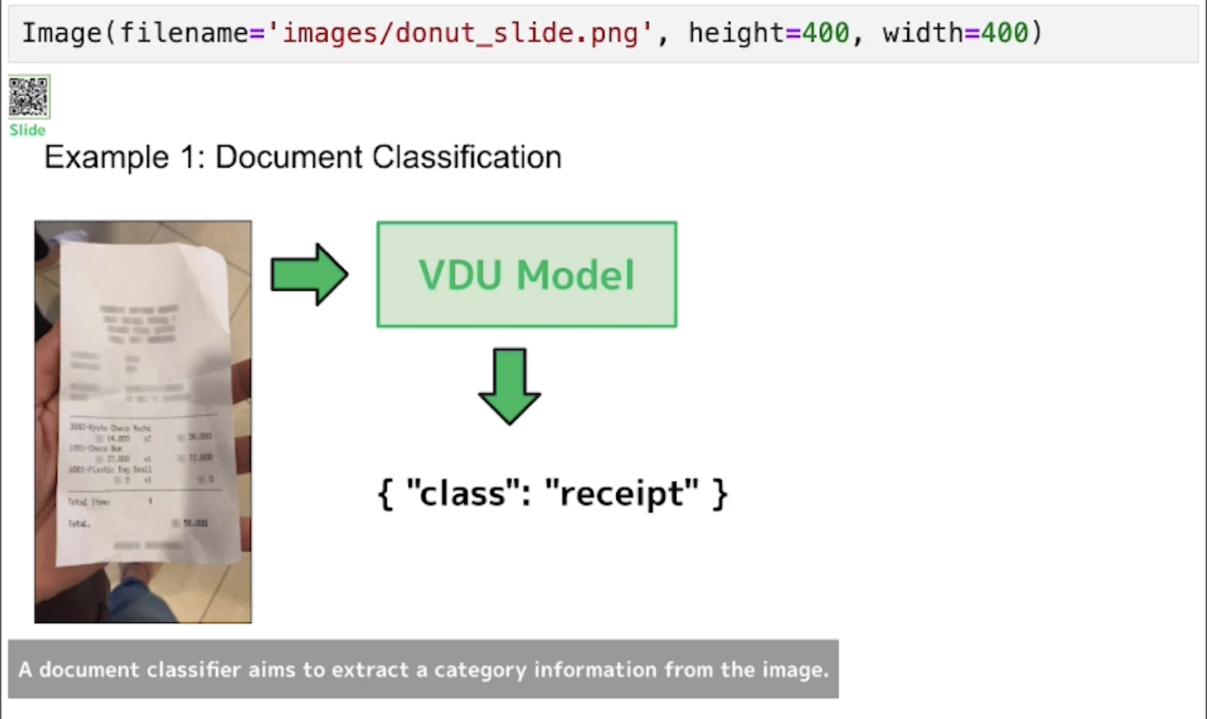

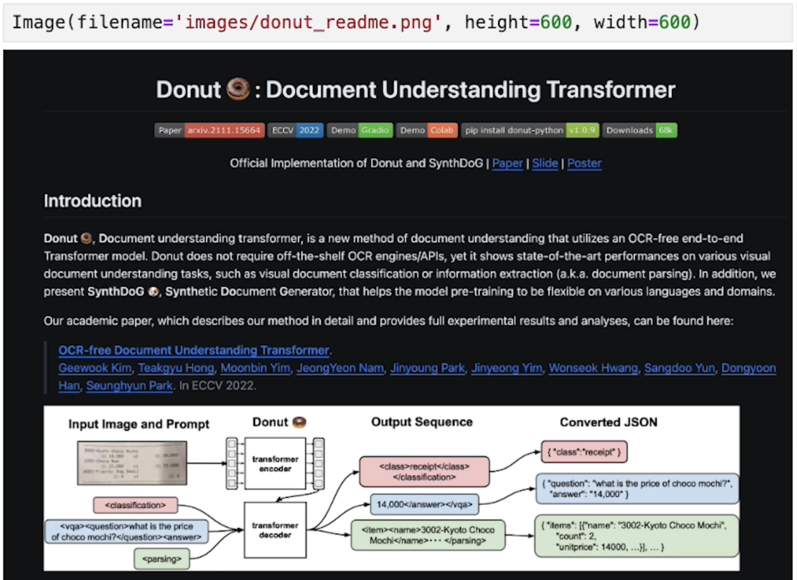

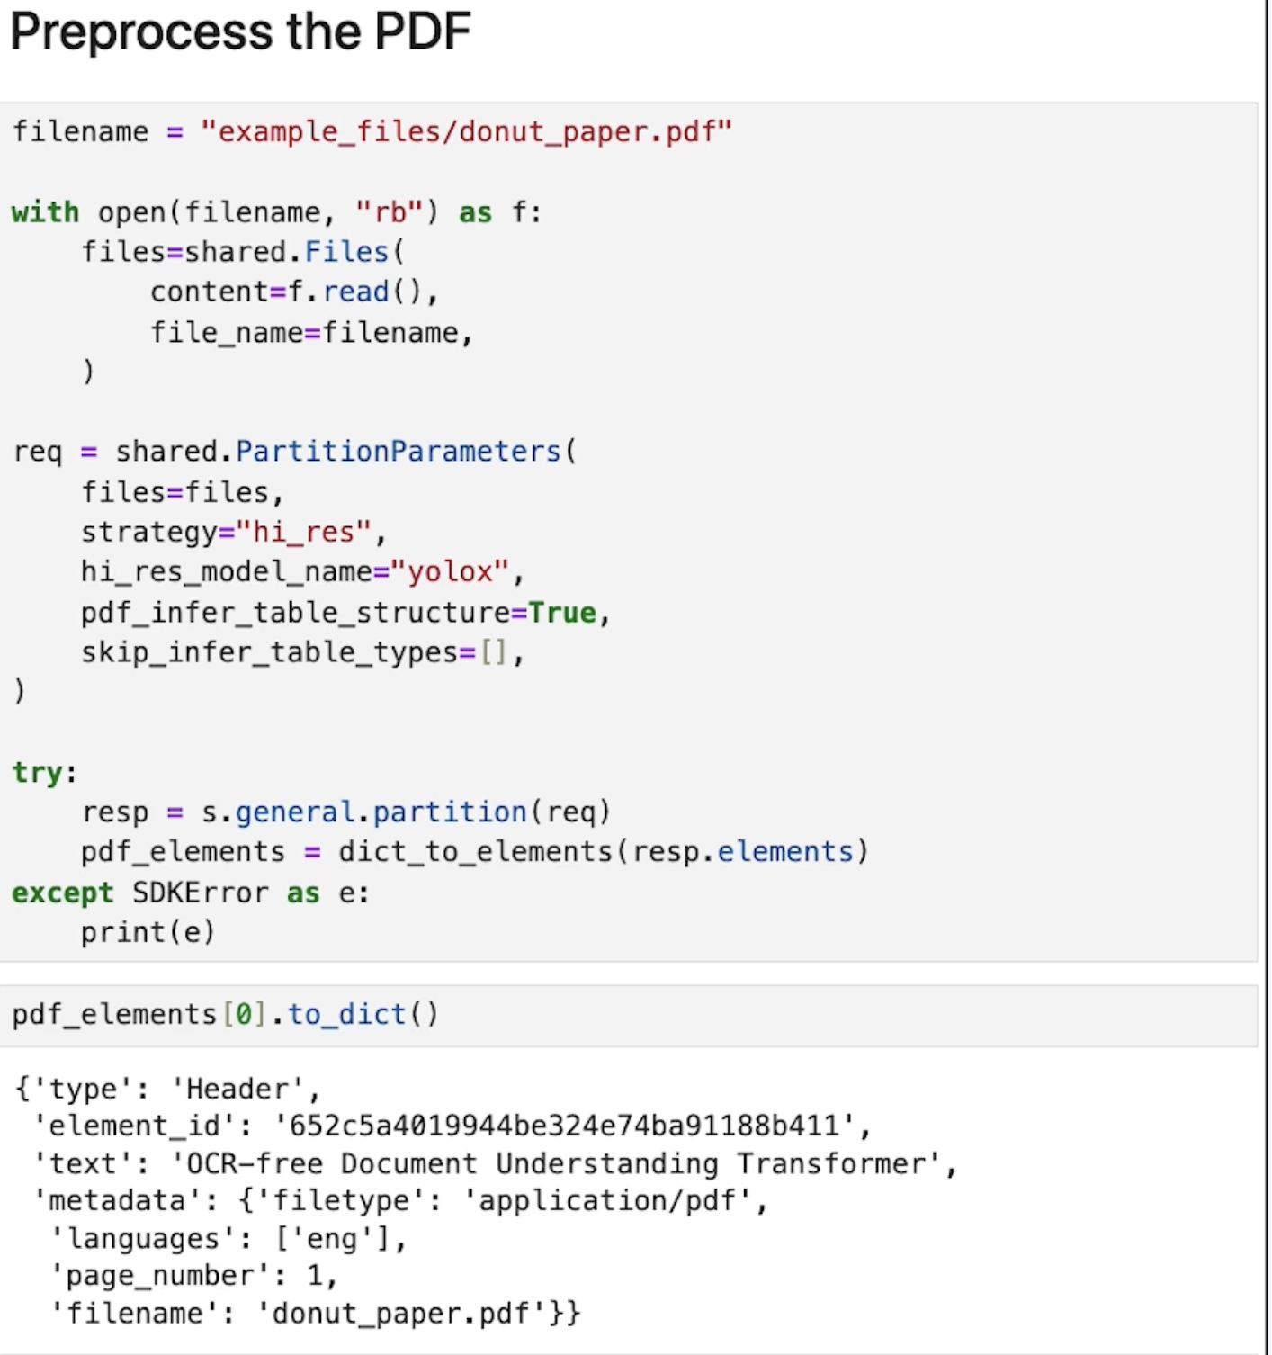

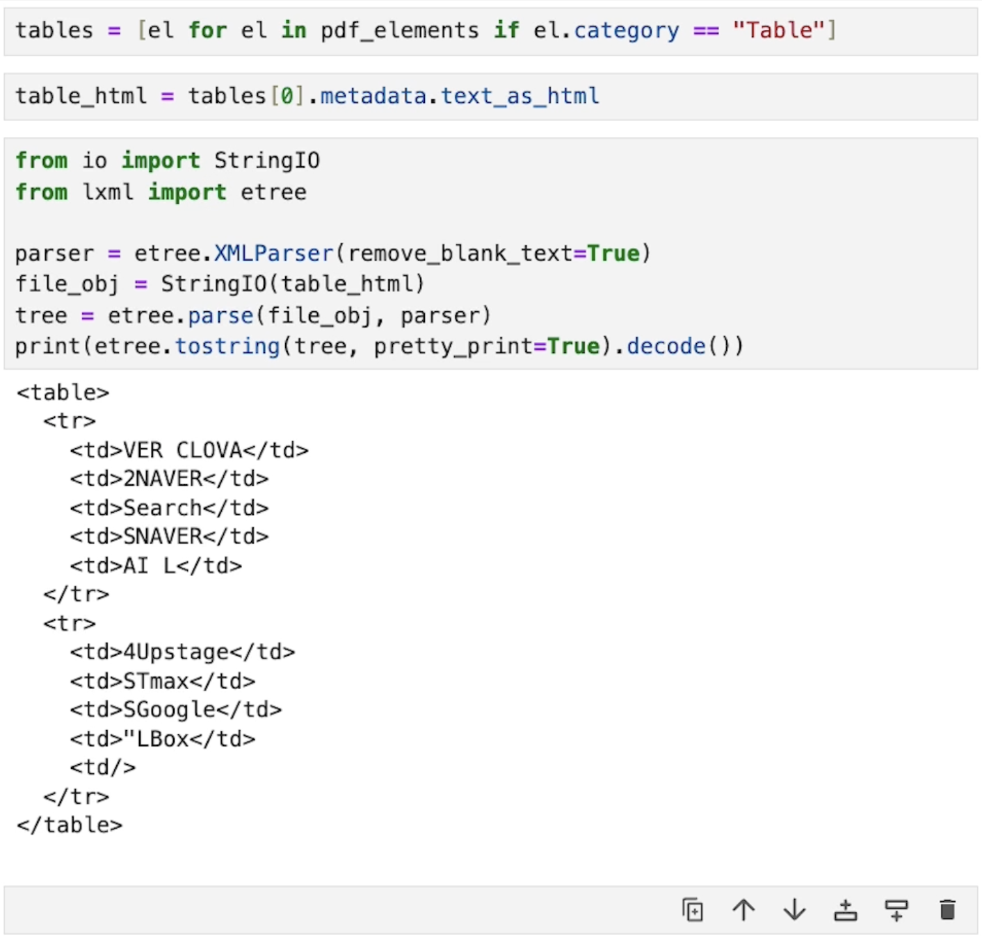

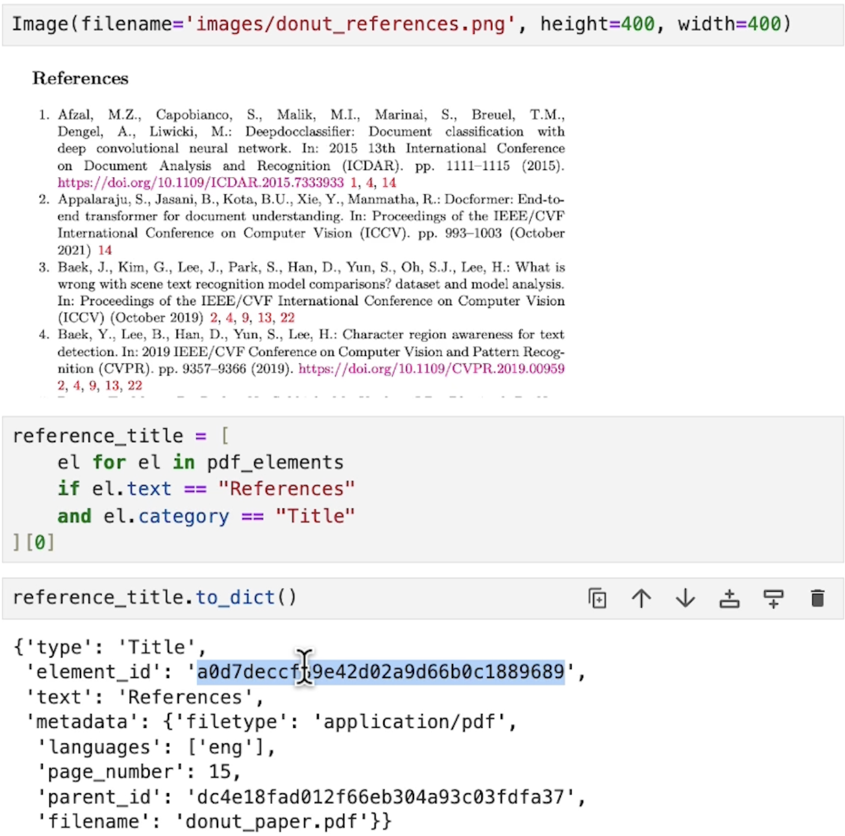

You can use the element id to filter:

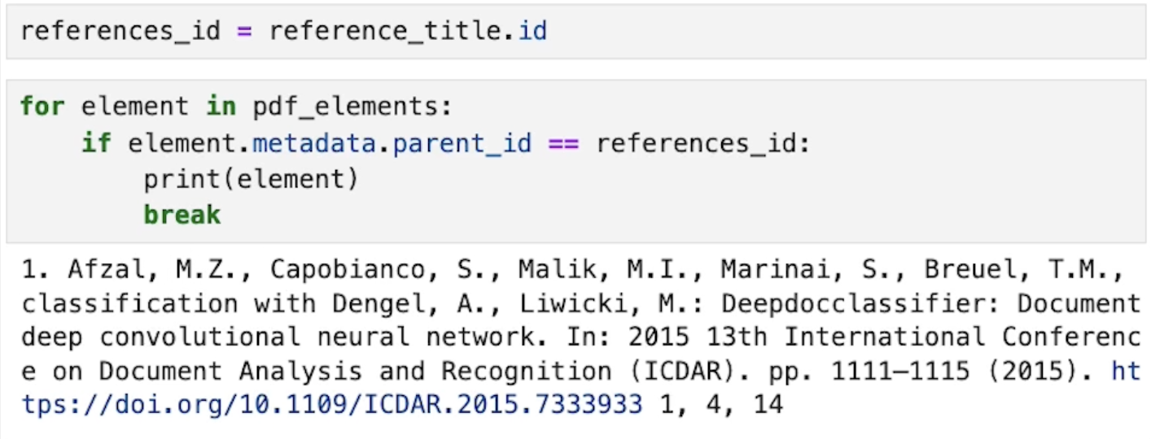

pdf_elements = [el for el in pdf_elements if el.metadata.parent_id != references_id]

